  Read to an adult and ask them to write in your reading record book. Do this 2 or 3 times a week. |   If you would like to, you can write in your reading record book yourself now you are in KS2! I have put some ideas of how to do this in your reading record books. | 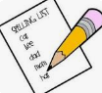  Once I have given you a homework spelling sheet, practice those spellings. Do this 2 or 3 times a week until you can spell all the words, then come and let me know! I will test you in school then move you on to another sheet.
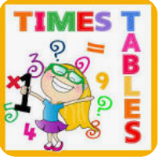  Practise the times table I have given you until you know the facts in any order. I will do a test in school then move you on to another times table. | Year 3 Homework  Autumn 1 | Have a go at this half term’s project. This half term it is about kites! See the next page for details.  
Can you read some books on the BOOK BINGO? Remember, for each one you read, you’ll get a house point; if you read 4-in-a-row, you’ll get a star up on the reading display and a chance to win a book prize! | Go on to T T Rock Stars and play some games. Your logins are in your reading logs.   |   You might get chosen to write in Our Favourite Books scrap book! You can write about your favourite book at home or at school and you can include pictures too.

