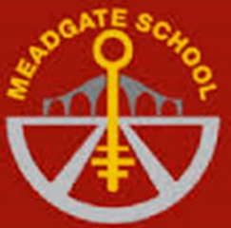
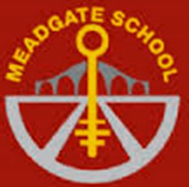
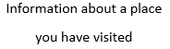
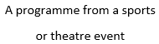
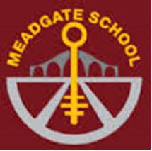
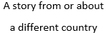
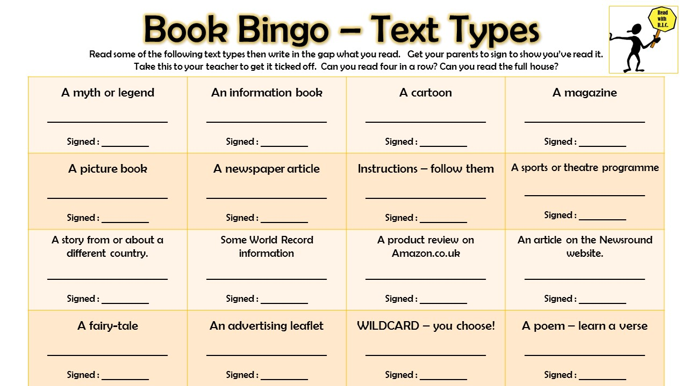
Get a House Point for each text type you read!
Get your name put up on display on a neon star and entered in a book raffle for every four in a row you achieve!
Can you follow a set of instructions to make something?
An atlas
A magazine
A comic or graphic novel
Listen to an audio book

