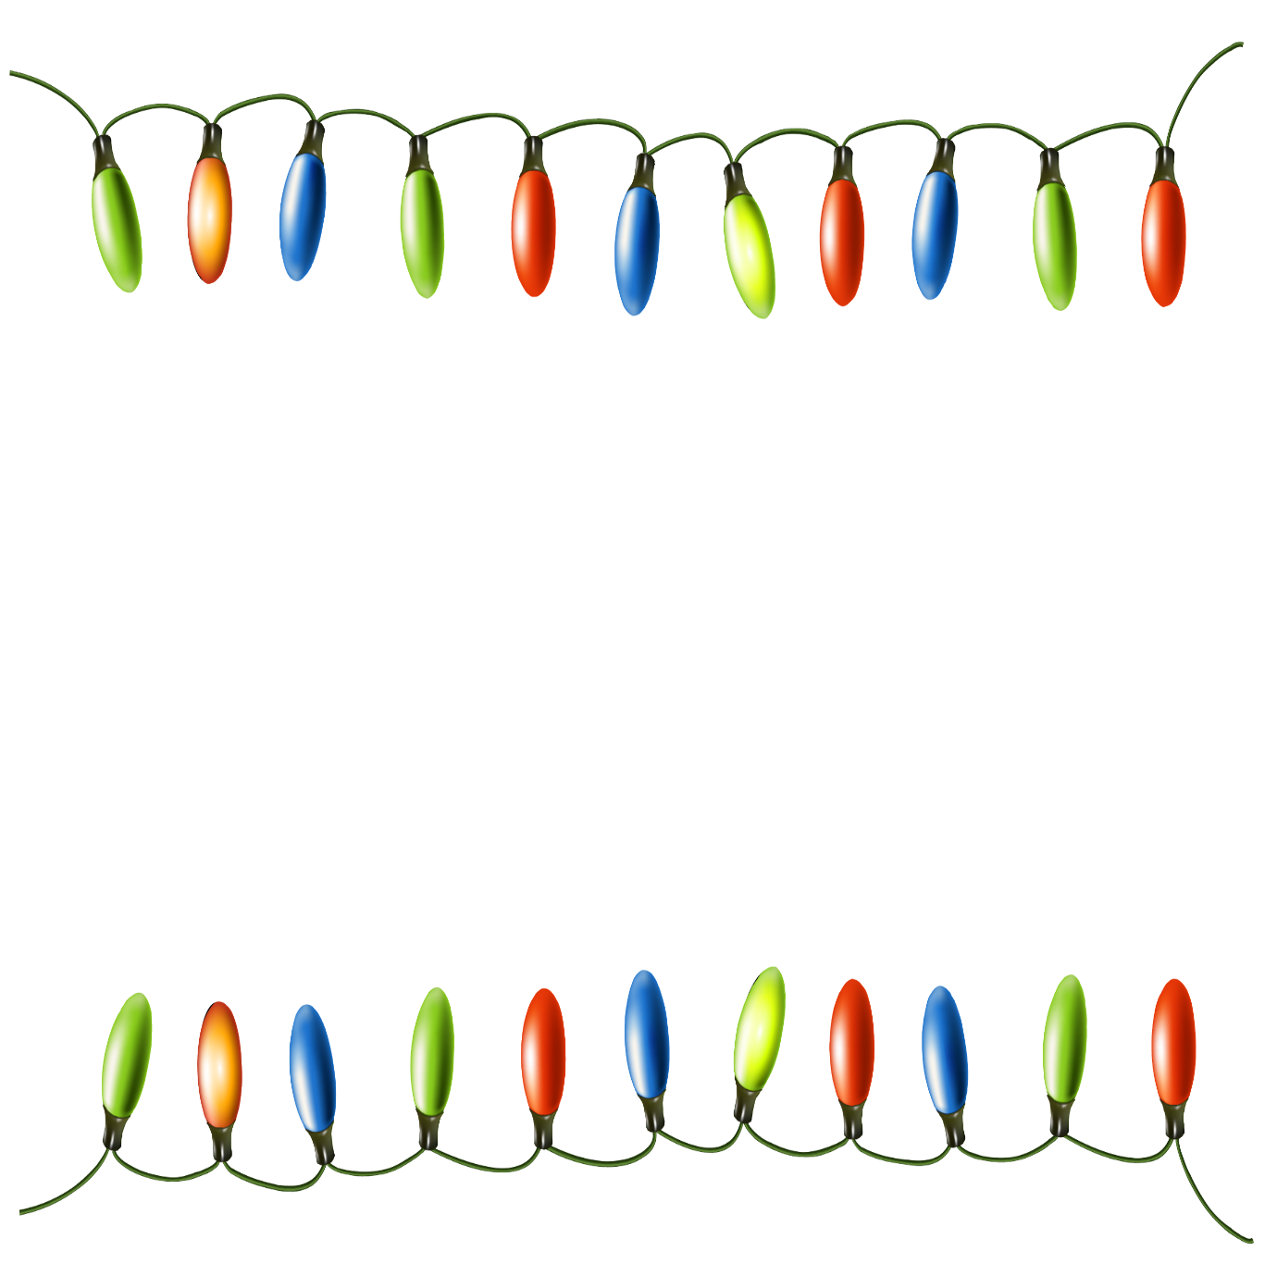
Year 3 Autumn 2 Homework Project – Light Festivals Research

Light festivals are celebrations where people use light to decorate, celebrate, and share joy. Examples include: Diwali, Hanukkah, Christingle, Advent or even the Winter Solstice.

- Choose a light festival and find out about it. When does it take place? What happens? Note down any facts which you think are interesting.

- Write up your research. You can handwrite it, adding your own drawings or you could write it on a computer and add digital images. Think carefully about the presentation.

- Hand it in to me! I will put your work on display and there will be house points rewarded for wonderful work!

