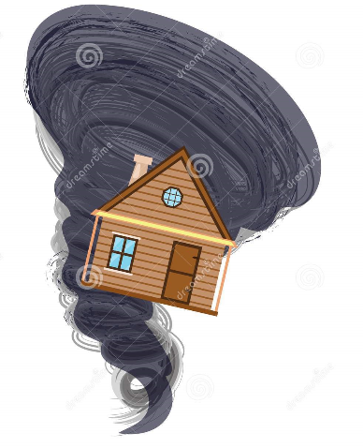 | 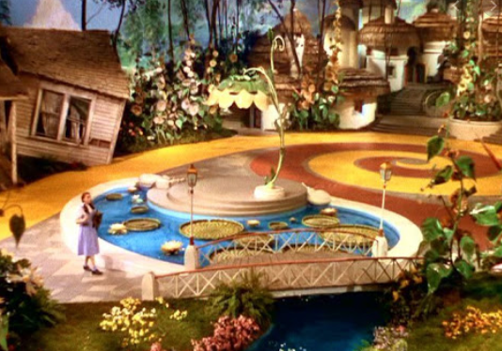 | 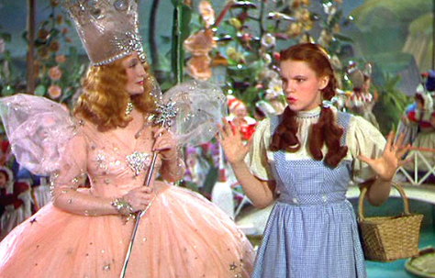
One day there was a tornado and Dorothy’s house flew up over the rainbow. | Dorothy found herself in Munchkin Land. Her house had landed on a witch! | A good witch came to help Dorothy. She told her to follow the yellow brick road.
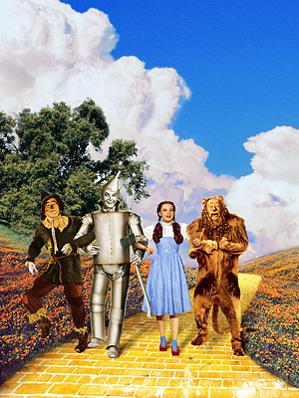 | 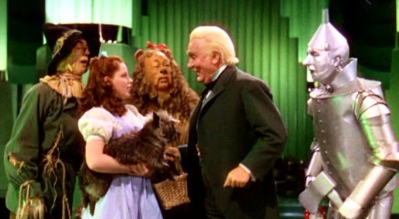 | 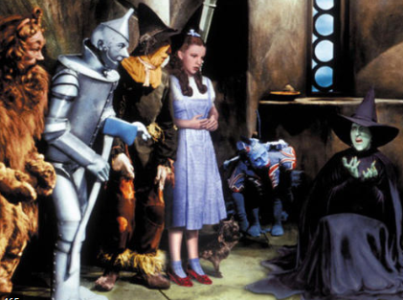
On the way Dorothy met a scarecrow, tin man and a lion. They became friends. | In the Emerald City she met the wizard of oz. He told her to get the wicked witch’s broom. | Dorothy found the wicked witch and threw water on her. She melted!
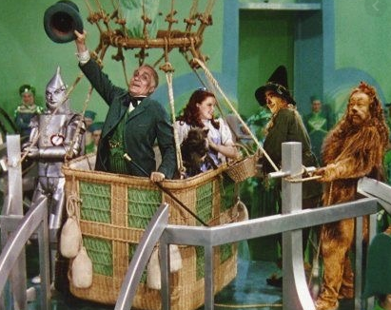 | 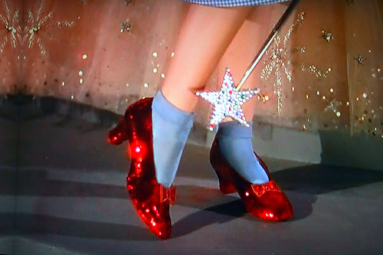 | 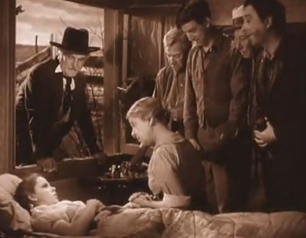
The wizard went to take Dorothy home in the hot air balloon but Toto ran off! Dorothy went after him. | Dorothy clicked her heels three times and said there’s no place like home. | She woke up back in her home with her family.

