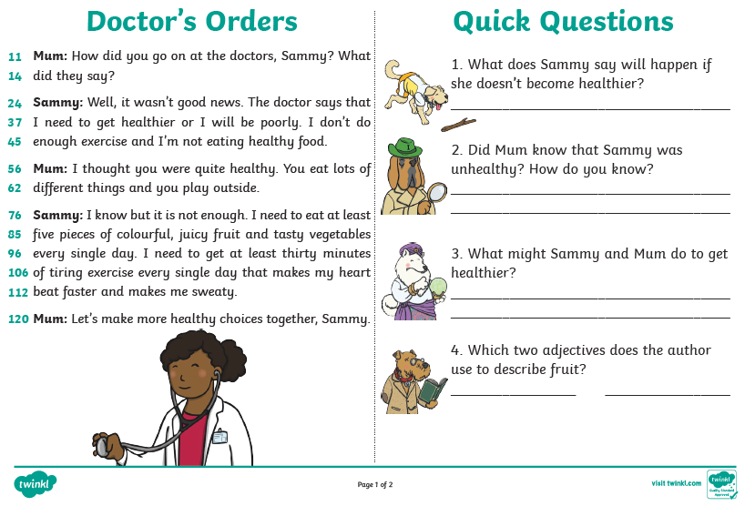

Week beg: 24.01.22. With some support from a family member, please complete the reading comprehension. You will receive a new one each week.