LO: I can count up to 20 accurately.

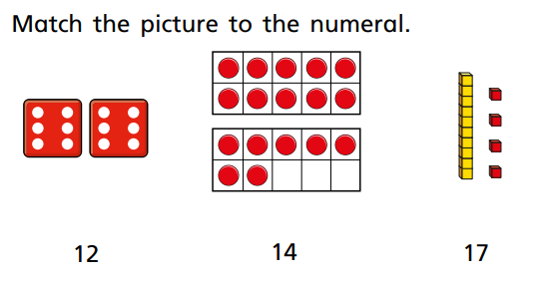

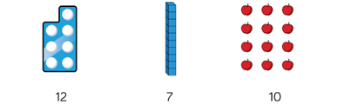

Make the number 19

