**Year 1 Summer Homework**

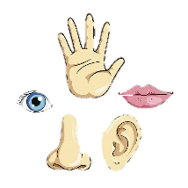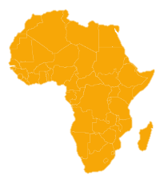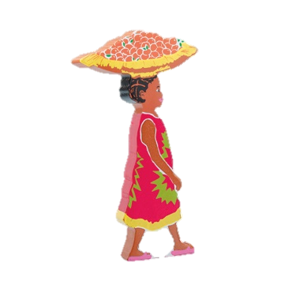Our topic the whole of the summer term is ‘On Safari’. Our lessons will focus on learning all about animals, African foods and prints, the senses and the story called Handa’s surprise.

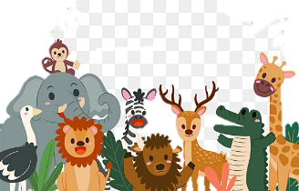There is one piece of homework to complete per week, in any order, but please do not feel pressured to complete every piece. We understand that family life can be very busy so just do what you can.

**Frequent** and **regular** reading with your child is the **most** important thing you can do so if you do nothing else - Read, Read, READ! We will continue to check reading logs every day. Even if all you can do is sign your name, this is enough to know you’ve read.

|  |  |  |
| --- | --- | --- |
| Homework Activity | Parent/Carer Comment | Teacher Comment |
| Choose two animals and compare them e.g. does it have fins, feathers, beak, scales, fur or tentacles? You could present your ideas in a table |  |  |
| Draw an example of an animal for each of the 5 types of animal: fish, amphibian, reptile, mammal and bird. Label them with their name and the type of animal they are. |  |  |
| Use your senses to explore somewhere. It could be your garden, the park or another place you visit. Write or draw what you see, hear, feel, smell and taste. |  |  |
| Use a Venn diagram to sort some animals into herbivores, carnivores and omnivores. |  |  |
| Draw a picture of yourself and label the parts of your body e.g. arm, leg, head, face, hand, foot, chest, knee, elbow, ankle, wrist, hips, thigh, shoulder |  |  |
| Can you do some research and find out some interesting facts about Africa? I can’t wait to see what you find out. You could use the internet or see if you can find some books on Africa. |  |  |
| Have a go at creating your own pattern. This could be geometric (shapes) or it could be images of something symbolic to you. |  |  |
| Practise reading and writing some harder to read and spell words. If you need a list, let me know and we’ll give you one. ☺ |  |  |
| Writing – Write down the characteristics you need to be a good friend e.g. To be a good friend, you need to be... |  |  |
| Writing – Write some sentences that use ‘and’ / ‘because’ to link them together e.g. I wore my coat outside because it was cold and raining. |  |  |
| Maths – Can you practise giving directions? You could use left, right, backwards and forwards and how many steps to take. |  |  |
| Maths – Play shops! Can you practise recognising coins, notes and count them up. |  |  |
| Maths – Practise telling the time! You could sing the days of the week song, the months of the year song and then practise telling the time to the hour e.g. 12 o’clock.  Challenge – maybe you could make your own clock. I have split pins if you’d like one ☺ |  |  |