**Year 1 Spring 1 Homework**

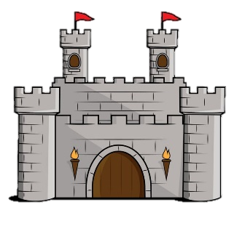Welcome back to school for 2025! We hope you had a magical Christmas and new year.

Our topic this Spring term is ‘Once Upon a Time’ and lots of our topic lessons will focus on learning about kings, queens, knights and castles. Try to complete as many homework activities as possible but as always, no pressure. Enjoying learning is the most important thing!

Mrs Francis and Mrs Leake

|  |  |  |
| --- | --- | --- |
| Homework Activity | Parent/Carer Comment | Teacher Comment |
| Set yourself some goals for the new year. What would you like to improve at? Handwriting? Reading? Maths? Nurturing friendships? |  |  |
| Can you draw your family tree? Maybe you can ask your older family members who came before them. |  |  |
| Compare a house/castle  Find a picture of a castle in a book or on the internet and compare it to your house. How is it different? How is it the same? You could record your results in a table e.g.   |  |  | | --- | --- | | Similarities | Differences | |  |  | |  |  |
| If possible, visit your local library and find a fairy tale you have not read before. Can you retell the story using pictures in your book? We will try to guess what story you read. |  |  |
| Practise your number bonds to 20. Can you see how similar they are to your bonds to 10. Talk about the patterns you notice with a grown up e.g. 8+2 = 10 so 18+ 2 = 20 |  |  |
| Design a crown. It can be any shape and as colourful as you’d like. Perhaps you could add crystals or stickers to it if you have any. We would love to see a photo of you wearing it. |  |  |
| Show and Tell  Lots of you love to do show and tell and we feel so bad when there is not always time for everybody to show something each day. To make it fair, we will do a show and tell afternoon each Friday so you will have a specific date and plenty of time to prepare something to bring in.  Friday 17th January- surnames starting with A-C  Friday 24th January- surnames starting with D-H  Friday 31st January- surnames starting with I-L  Friday 7th February- surnames starting with M-N  Friday 14th February- surnames starting with O-Z.  It could be a photograph of a special family day out, or even a cool craft you have made/built at home. Prepare a few sentences to say about it to your friends in class. |  |  |