**Year 1 Autumn 1 Homework**

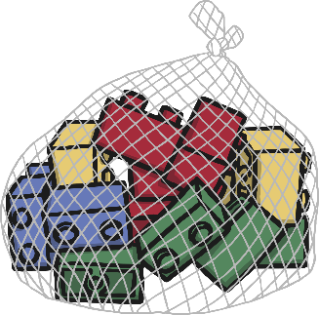Our topic this half term is ‘Terrific Toys’ and lots of our topic lessons will focus on learning about toys now and in the past. There is one piece per week to complete but do not feel pressured into completing every piece. We understand that family life can be very busy so just do what you can manage. Regular reading with your child is the most important thing you can do so if you do nothing else- Read, Read, READ**!**laugh

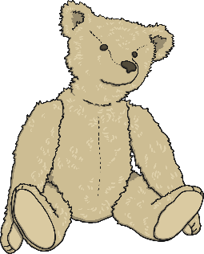

|  |  |  |
| --- | --- | --- |
| Homework Activity | Parent/Carer Comment | Teacher Comment |
| **Writing**  Continue to practise your letter and number formation. Capitals and lower case. |  |  |
| **Drawing**  Draw your favourite toy and write a sentence to tell us why it is your favourite. |  |  |
| **Talking**  Talk to someone in your family about the toys they used to play with as children? Were they different or similar to the toys you play with now? What materials were they made out of? |  |  |
| **Art**  Find as many pictures of toys as you can and stick them in your book to create a toy collage. You could use magazines, newspapers or catalogues. You could also add photos or pictures of your own toys or toys that other family members play(ed) with. |  |  |
| **Reading**  Aim to read your school colo9ured reading book 5 times a week for fluency. |  |  |
| **Maths**  Practise counting forwards and backwards from any given number. |  |  |
| **Science**  In line with our materials topic, can you help your family to sort your rubbish into recycling? |  |  |