  Maths  Log on to T T Rock Stars and practise for 20 minutes – keep those times table skills sharp!  Then log on to Hit the Button Hit the Button - Quick fire maths practise for 6-11 year olds (topmarks.co.uk)  Practise your square numbers and division facts! |   Geography - Maps and Mapping  - Log on to Purple Mash.  - Try these quizzes set as To dos! They will help you remember facts from our Atlas scavenger hunt!  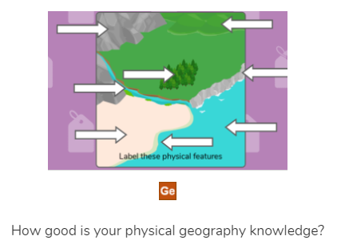  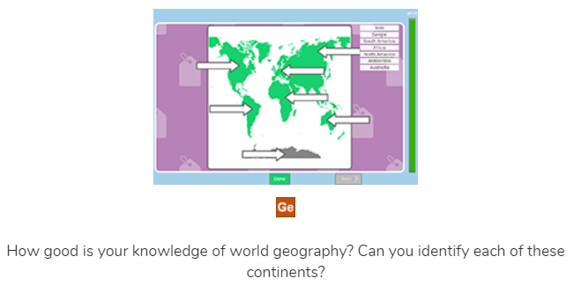  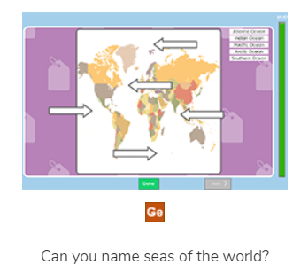
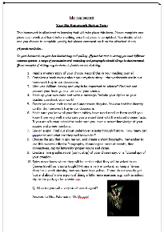  Homework  Use this time to get going on your Sh! Top Secret! homework!  Here is a link to your homework sheet in case you have lost it: top_secret_homework_1.docx (live.com) | 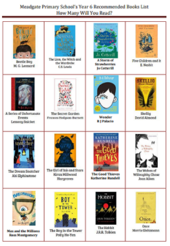  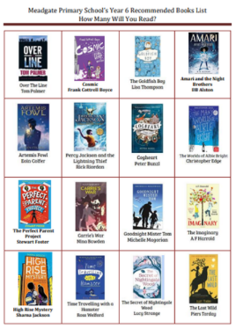  Reading  Now is a great time to see if you can get going on our KS2 Reading Challenge – How many books can you read from the Year 6 booklist? Here is a link to the book list in case you have mislaid yours: Meadgate Primary School’s Year 6 Recommended Books List How Many Will You Read? (primarysite-prod-sorted.s3.amazonaws.com) Maybe you could make a cosy reading den at home and have a really relaxing long read.  You could also set a 10 minute timer and challenge yourself to read in a pacey way like we have done twice in school this week.  If you need to browse for a book, try our virtual library: Meadgate Primary's Virtual Library | Meadgate Primary School Ms Pateman

