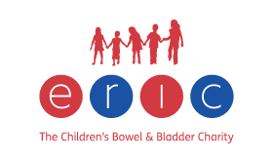



**For detailed information and numerous resources please follow the link:**

[**https://www.eric.org.uk/**](https://www.eric.org.uk/)

ERIC, The Children's Bowel & Bladder Charity has been dedicated for over 30 years to improving the lives of all children and teenagers in the UK facing continence challenges.

**They offer:**

* a helpline for families to talk to or email an expertly trained childhood continence advisor
* information and downloadable guides on potty training, bowel problems (constipation & soiling), daytime bladder problems and bedwetting
* training courses for health and education professionals
* parent & carer workshops to inform and give support on potty training and bowel & bladder conditions
* an online shop supplying a range of life-transforming continence products
* campaigns to raise awareness of the causes and treatment of children's bowel and bladder problems and to improve support available to children in education settings and the NHS.