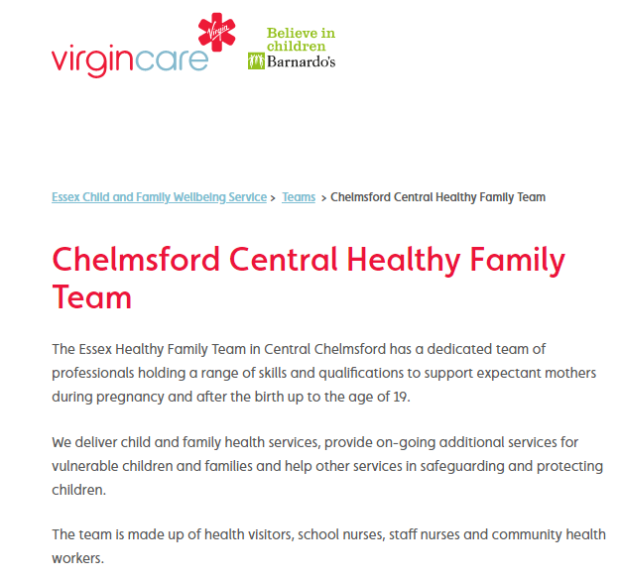

For full details of support and information follow the link:

<https://essexfamilywellbeing.co.uk/team/chelmsford-central/>

Or call: Mid Essex - **0300 247 0014**

