Keeping Safe

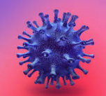

Coronavirus is a virus. A virus is a very tiny germ which we can’t see.

We don’t always know who has the virus in their body.

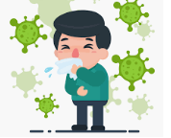

Coronavirus can make people very poorly, they can feel tired and

have a cough and a high temperature.

I have been staying at home with my family to help stop the virus

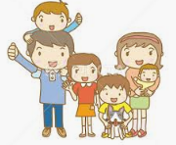

from spreading. I couldn’t go to school and my family have helped

keep me safe.



My school is now open and I can go back.



It will be nice to see some of my friend’s faces and some

of my teacher’s faces too.

It is VERY important that I remember I can’t go very close to my friends and teachers and I can’t touch them.

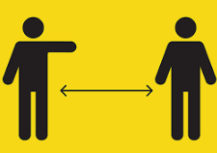

I will be excited to see them but I MUST keep a big gap between us so we are safe. I can let them know I am happy by:

Waving at them,

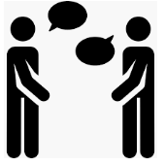



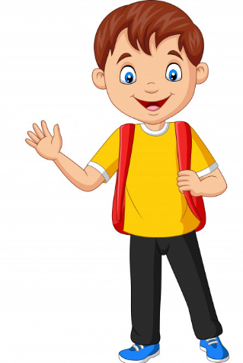

Smiling at them

Talking to them across the gap

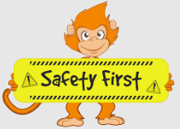

The adults in school will keep me safe when I am there and

remind me during the day to keep a gap between me and other

people so I keep everyone else safe too as well as me.

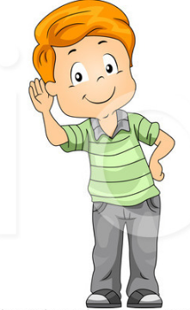

It will be lovely to go back to school but I must make sure I listen

and stay safe!