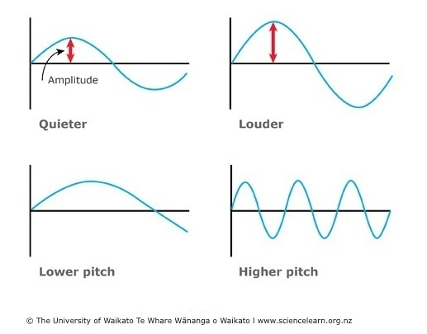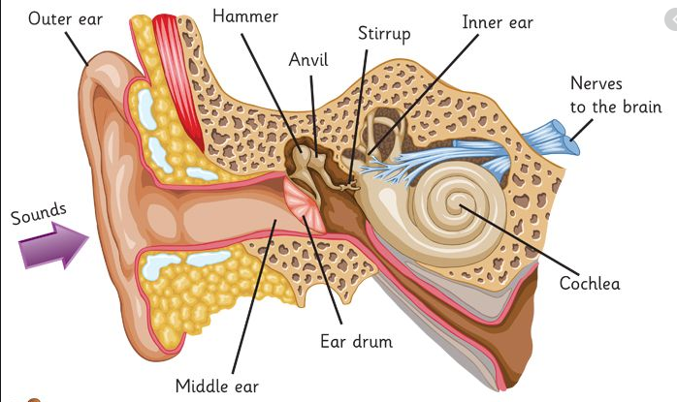

Sound passes more easily through solid objects because the particles are closer together.

Pitch is how high or low a sound is.   
The faster the vibrations, the higher pitch.

Sound is a type of energy.

Vibrations hit the eardrum, passed through the ear, then changed into electrical signals and sent to the brain. The brain tells us what we are hearing.

**Amplitude** is the size of a vibration.   
The larger the amplitude, the louder the sound.

Sounds are created by vibrations. Sound can travel through solids, liquids and gases, but not through a vacuum.

**Sound**