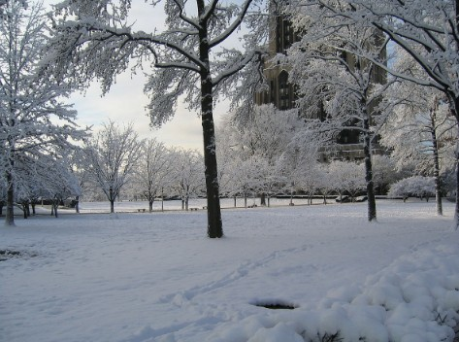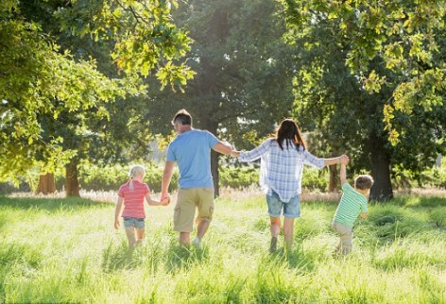

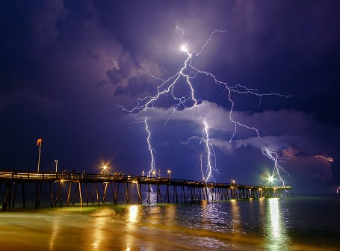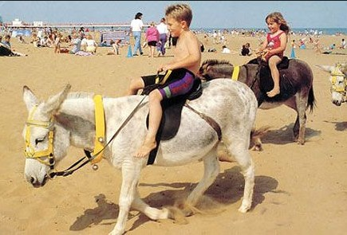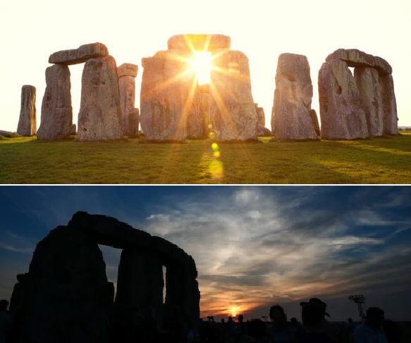

**The Seasons**

|  |  |  |
| --- | --- | --- |
|  | | There are 4 Seasons. The Seasons are Spring, Summer, Autumn, and Winter.  The Seasons occur in a cycle. |
| AUTUMN | | September, October and November |
| WINTER | | December, January and February |
| SPRING | | March, April and May |
| SUMMER | | June, July and August |
| AUTUMN FEATURES |  | **Harvest** time is in this season.  Temperatures drop. Skies can be **overcast**.  Birds **migrate** to warmer climates.  Leaves change colour and fall from **deciduous**  trees. |
| WINTER FEATURES |  | The coldest time of year. We sometimes see snow,  **frost** in the morning, **sleet**, **blizzards**, and **hail.** Water freezes to ice. Many plants stop growing. Some animals including **hedgehogs** and **tortoises**  **hibernate.** |
| SPRING FEATURES |  | In this season temperatures rise and the earth starts to warm up. Flowers begin to grow. This season is associated with rebirth and growth, some baby animals are born (e.g. lambs, chicks) |
| SUMMER FEATURES |  | The hottest time of the year. There is usually sunshine, generally dry weather but there may be thunderstorms too!  Flowers and trees are in **bloom**. |
| **Summer solstice** |  | The longest day of the year. In the UK it falls on June 21st. |
| **Winter solstice** |  | The shortest day of the year.  In the UK it falls on December 21st. |
| **Spring** and  **Autumn**  **Equinox** |  | There is an equal amount of daylight and night. |