

**Animals Including Humans**

**Year 4**

**visit twinkl.com**

**Key Knowledge**

**Key Vocabulary**

**digest**

Break down food so it can be used by the body.

**oesophagus**

A muscular tube which moves food from the mouth to the stomach.

**stomach**

An organ in the digestive system where food is broken down with stomach acid and by being churned around.

**small intestine**

Part of the intestine where nutrients are absorbed into the body.

**large intestine**

Part of the intestine where water is absorbed from remaining waste food. Stools are formed in the large intestine.

**rectum**

Part of the digestive system where stools are stored before leaving the body through the anus.



**Human Teeth and Their Functions**

**canine**

tears and rips

**incisor molar**

bites grinds

and cuts

**premolar**

holds and crushes

Some people have wisdom teeth but they have no function now.

**Key Knowledge**

**The Digestive System**

**tongue**

**teeth oesophagus**

**mouth**

**salivary gland**

**stomach**

**liver**

**gallbladder pancreas**

**duodenum large intestine**

**rectum small intestine**

**anus**

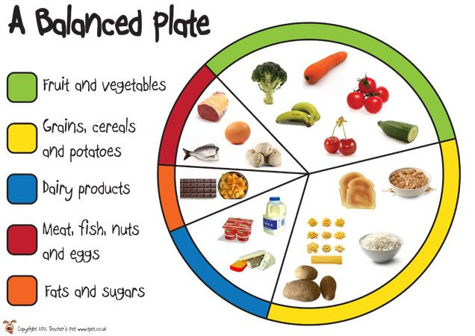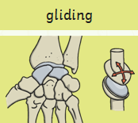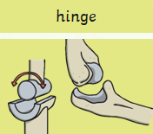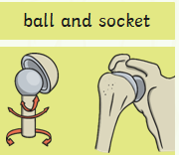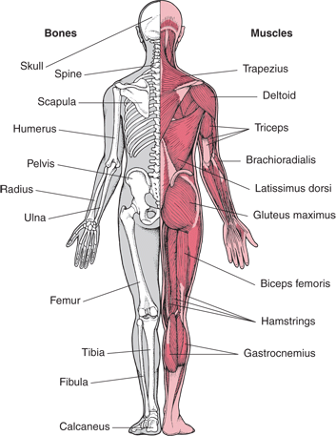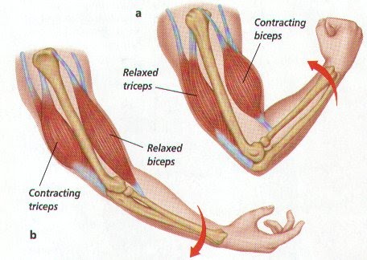

Food groups

* Vitamins and minerals
* Fibre
* Carbohydrates
* Calcium
* Protein
* Fats

**Nutrition recap**

Bones can “glide” over each other for small movements in different directions.

*Example: wrist*

Flex and extend movements.

*Example: elbow*

Allow the most freedom of movement.

*Example: shoulder*

**Types of joint:**

1. Gives us **shape**
2. **Protects** internal organs
3. Works with the muscles to allow us to **move**

**3 main jobs of the skeleton:**

**How do muscle and bones work together to help us move?**

One muscle pair **contracts** (gets smaller) to bend, whilst the other **relaxes**.

Muscles pull on bones to allow us to move.

**Human – omnivore (plant**

**and meat eater)**

**Lion – carnivore (meat eater)**

**Elephant – herbivore (plant eater)**

The teeth of an animal are designed to eat different foods depending on the diet of the animal. Examples of a **herbivore**, a **carnivore** and an **omnivore** skull:

**incisors incisors**

**canines** **carnassial** incisors **teeth**

**incisors premolars canines molars molars premolars**

**An Example of a Food Chain** consumer consumer consumer The arrows in a primary consumer secondary consumer tertiary consumer food chain show the **prey predator**/**prey predator** flow of energy. **producer**

**Animals Including Humans**

**Year 4**