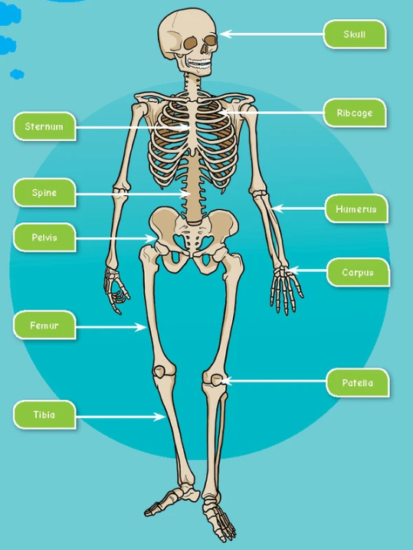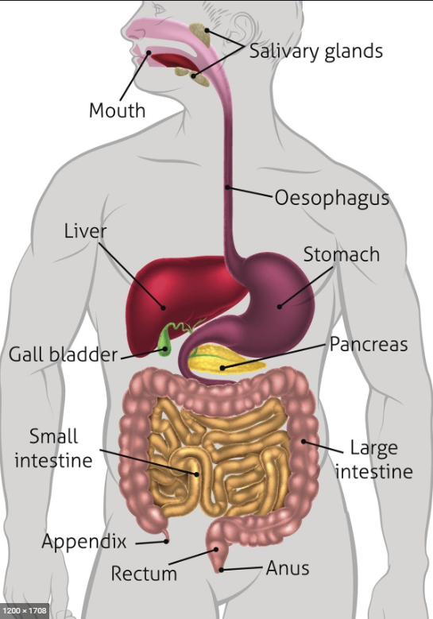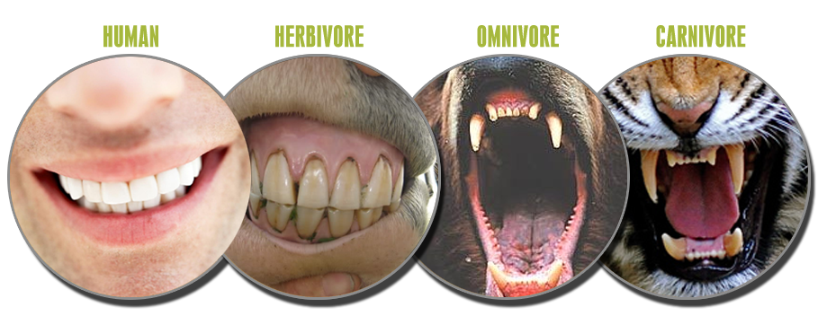

The 4 types of teeth are incisor (biting and cutting), canine (tears and rips), premolar (holds and crushes) and molar (grinds down).

Humans and animals have 4 types of teeth, which differ according to their planet and/or meat based diets.

Three types of joint allow different movements; ball and socket, hinge joint and gliding joint.

**Animals including Humans**

**(Marvellous Me)**

The skeleton has 3 main jobs: shape, protection, movement.

Muscles and bones work together to allow movement.

The human digestive system involves several internal processes to break down the food that we eat, so that nutrients and energy can be provided to the body.

Muscles work in pairs to move joints. When one contracts, the other relaxes.

To maintain health and function, a human body needs the right amount of vitamins, minerals, fibre, carbohydrates, calcium, protein and fats within a balanced diet.