**My Knowledge Organiser – Magnets Year 3**

**Vocabulary**

|  |  |
| --- | --- |
| Magnet | A metal object that pulls another object towards it using a magnetic force |
| Magnetic | An object that is attracted to a magnet. Objects made of nickel or iron are magnetic |
| Force | Scientist call forces pushes or pulls. Forces can start something moving, slow something down or make it stop |
| Attract | When something is attracted to a magnet, it moves towards it and sticks to it |
| Repel | When something is repelled by a magnet, it moves away from it |
| Pole | Magnets have 2 poles called the North and the South Poles at the ends |
| Magnetic field | This is the area around a magnet where is has a magnetic force on an object |

The Poles of a Magnet

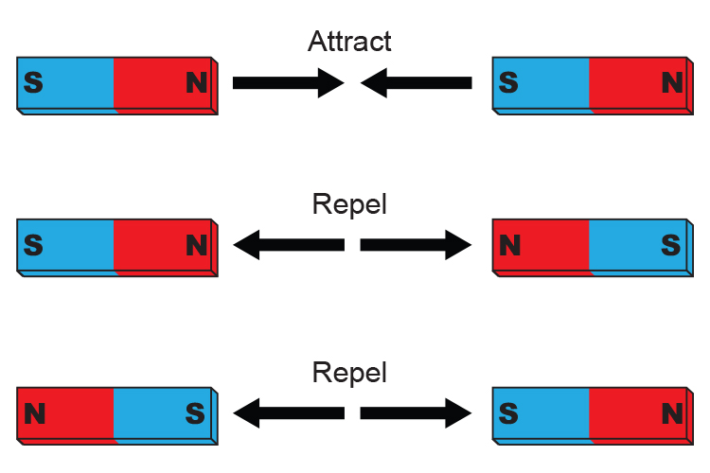

The Poles of a magnet are found at the ends of the magnet.

They are called the North and the South Pole

Magnetic Field

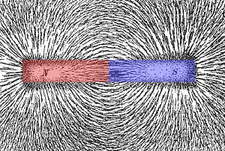

Tiny iron filings are placed on this magnet to show the shape of its magnetic field.

Magnets at Work

We can group magnetic materials and non-magnetic materials together.

Magnetic Materials Non-Magnetic Materials

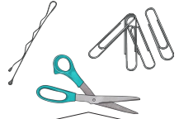 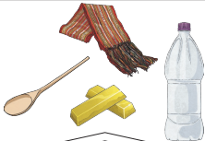

Magnets can work through some materials but not all

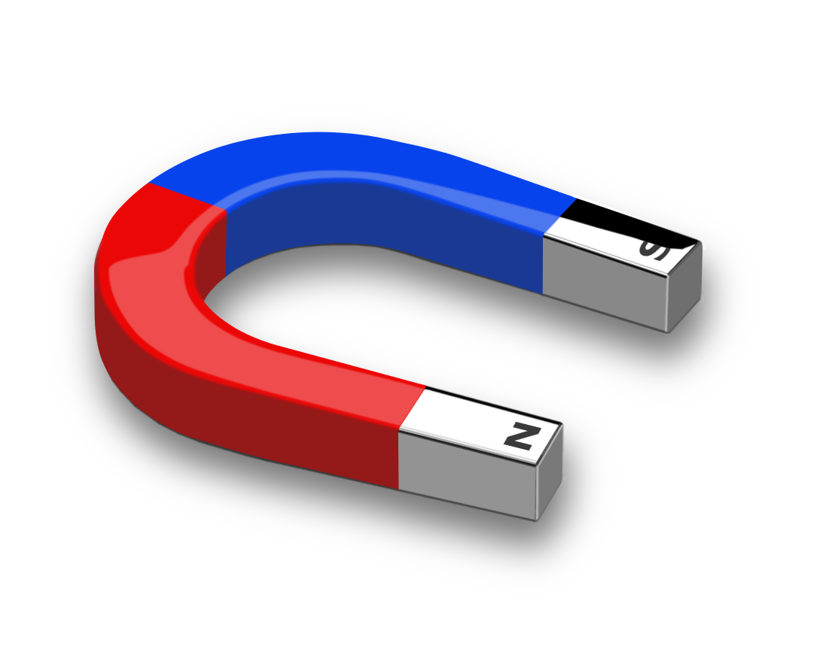 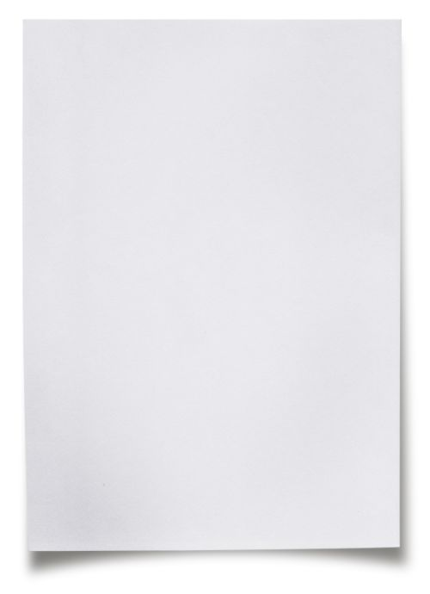 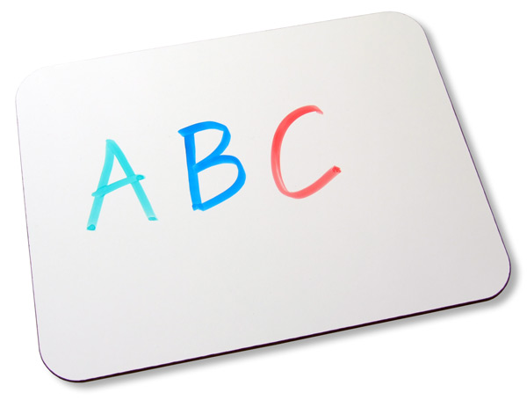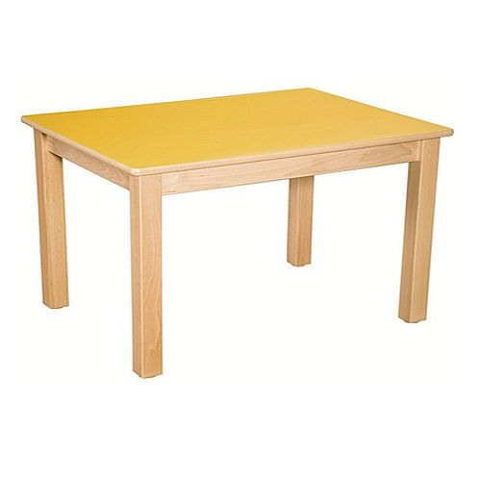

Unlike forces, magnets do not need to touch the object they attract.

Magnetic Strength

Magnets may be stronger or weaker than other magnets.

Bigger magnets are not always stronger.

We can test how strong a magnet is.

