|  |  |
| --- | --- |
| **Key Vocabulary** | |
| **Sun** | A huge star that Earth and the other planets in our solar system orbit around. |
| **star** | A giant ball of gas held together by its own gravity. |
| **moon** | A natural satellite which orbits Earth or other planets. |
| **planet** | A large object, round or nearly round, that orbits a star. |
| **sphere** | A round 3D shape in the shape  of a ball. |
| **spherical bodies** | Astronomical objects shapes like spheres. |
| **satellite** | Any object or body in space that orbits something else, for example: the Moon is a satellite of Earth. |

Our Solar System

Year 4

Earth and Space

orbit

celestial bodies

Saturn

Earth

Jupiter

Mercury

Mars

rotate

Venus

axis

Sun

Uranus

Neptune

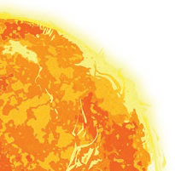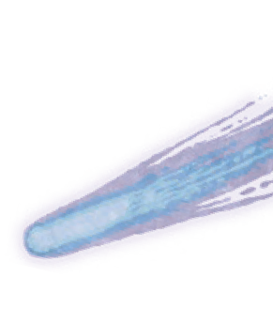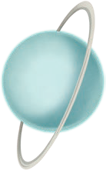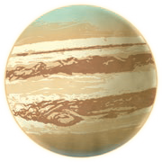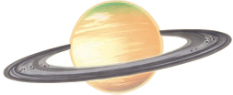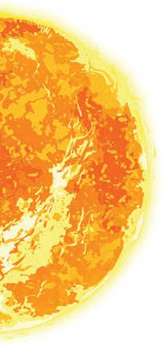

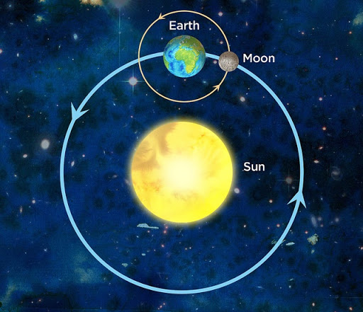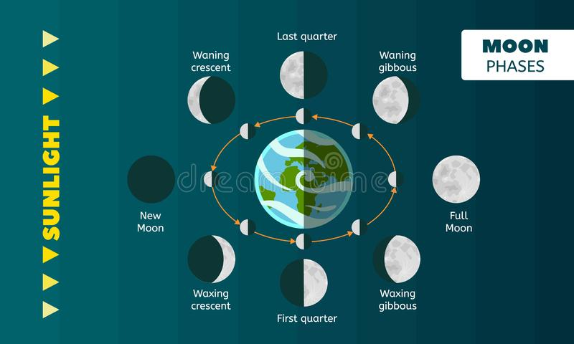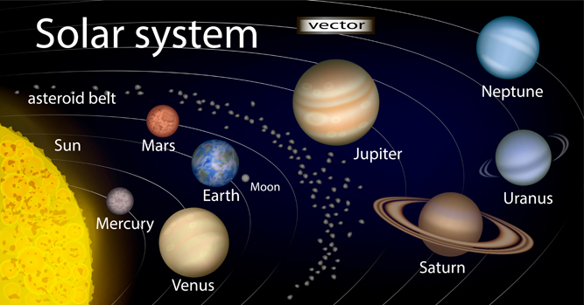

The Moon orbits Earth in an oval- shaped path while spinning on its axis. At various times in a month, the Moon appears to be different shapes. This is because as the Moon rotates round Earth, the Sun lights up different parts of it.

|  |  |
| --- | --- |
| https://forum.wordreference.com/proxy.php?image=http%3A%2F%2Fwww.mstworkbooks.co.za%2Fnatural-sciences%2Fgr7%2Fimages%2Fgr7eb01-gd-0020.png&hash=5aa7e80108401a633399d5bb234051ac**Key Vocabulary**   * The Sun seems to move across the sky. This is because our planet both spins on its axis and orbits the **Sun.** * Because of the tilt of the Earth, the sun appears lower in the sky in winter than in summer.   **Key Knowledge**  Year 4 | |
| **orbit** | To move in a regular, repeating curved path around another object. |
| **axis** | An imaginary line that a body rotates around. E.g. Earth’s **axis** (imaginary line) runs from the North Pole to the South Pole. |
| **rotate** | To turn on an axis (Earth rotates once every 24 hours on its axis)  Seasons  Day and Night |
| **revolve** | Image result for earth movementTo follow a circular path in orbit (Earth revolves around the sun every year)  The Earth rotates **one** complete turn every **24 hours** to give us day and night.  When Britain faces the Sun it is daytime in Britain but the other side of the world is in darkness.  Over a year, the length of the daytime where you live changes. Days are **longer** in the summer and **shorter** in the winter. |
| **equinox** | When the sun's rays are **closest** to the Earth's equator, occurring in March and September.  During the equinox, day and night are both 12 hours long all over the world. |
| **solstice** | When the sun’s ray are **furthest** from the equator, occurring in June and December |

Earth and Space

Earth rotates on an axis.

During the **winter**, the Northern hemisphere is tilted **away** from the Sun's rays.

As Earth travels around the Sun, the tilt of Earth changes.

By the **summer**, the Northern Hemisphere is tilted **towards** the Sun and the days become much longer.

Earth takes a year to orbit the Sun and it is the tilt which creates the seasons.

**Time on Earth**

* 1 day = **24 hours**

(Earth spins once on axis)

* 1 month = **28 days**

(Moon orbits Earth once)

* 1 year = **365 days** (366 in a leap year)  
  (Earth orbits sun once)
* **Leap years** happen every **4 years**, because each year is 365 days and a quarter. 4 quarters = 1 whole day We have **29th February** as the extra day.

