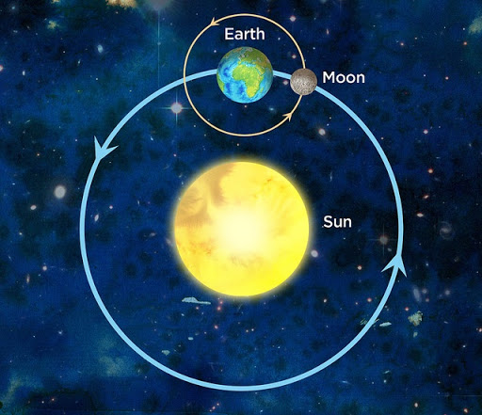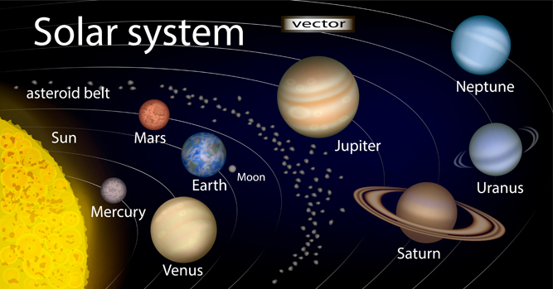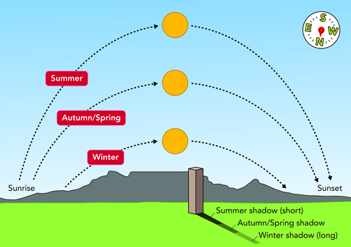

We have day and night because the Earth spins on its axis.

Earth is tilted at an angle of 23.5 degrees, which causes seasons as Earth orbits the sun.

The moon orbits Earth and appears to be different shapes because the sun lights up different parts of its surface.

All planets in our solar system are roughly the shape of a **sphere**.

All planets in our solar system orbit the sun, which is a star.

1 day = 24 hours

1 month = 28 days

1 year = 365.25 days

Leap year = every 4 years

The Sun appears to move across the sky because our planet both spins on its axis and orbits the Sun.

**Earth and Space**