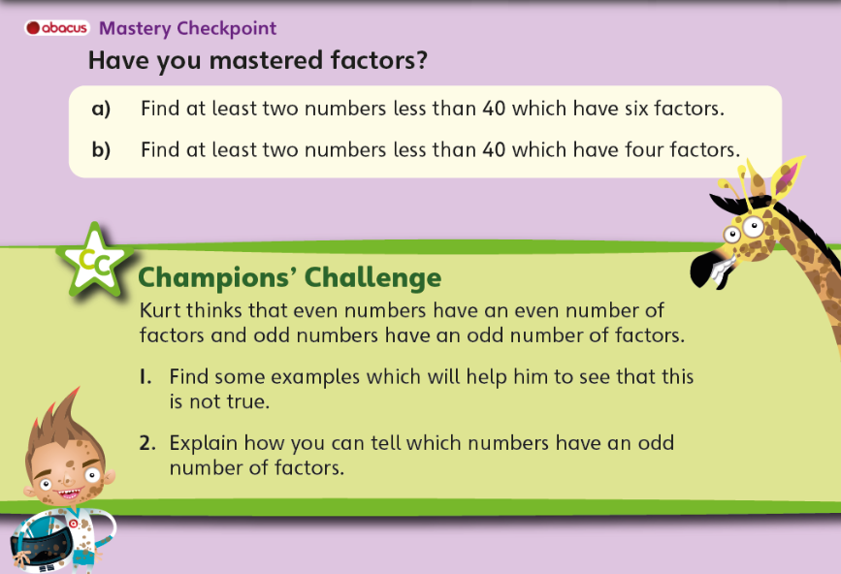

**DO NOT LOOK AT THE ANSWERS BELOW UNTIL YOU ARE FINISHED!**

