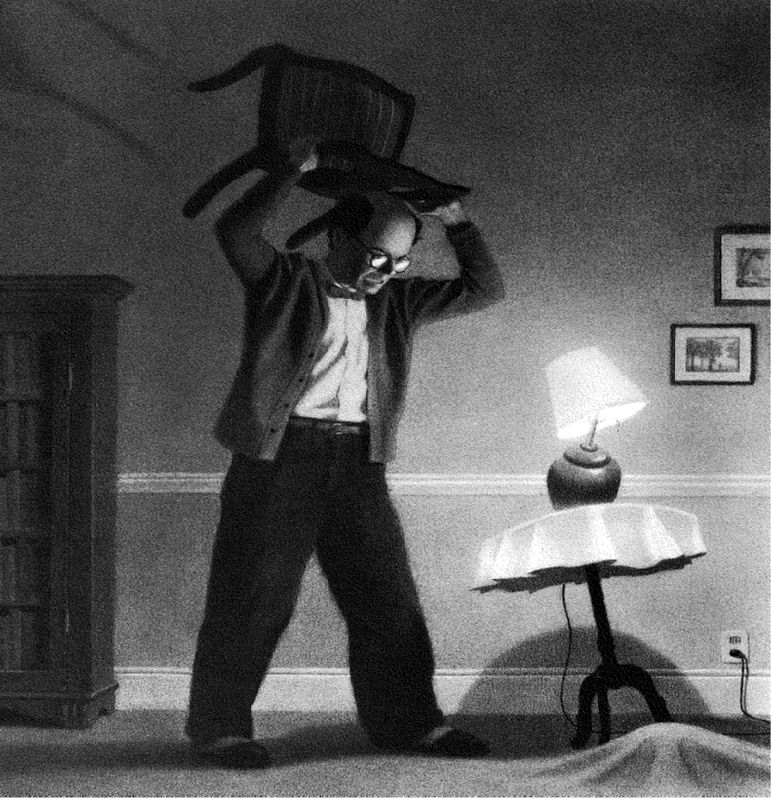

Was it really happening again? He just couldn’t believe his eyes…

Use this opener to write a story based on the image above.

Remember to use full sentences, capital letters and full stops.

Include adjectives and adverbs for description.

Write complex sentences using conjunctions.

Include a small amount of dialogue and punctuate it correctly.

Can you use a variety of punctuation too?

Read your work back to yourself and edit where necessary.

Can you include any of the skills we have learnt? Think back to our green slides…