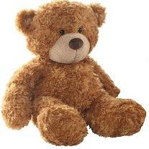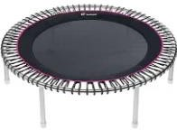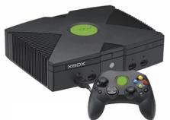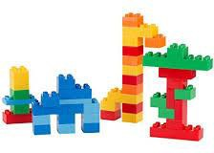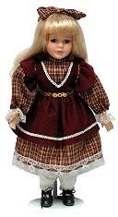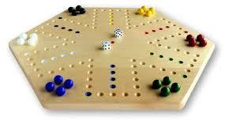

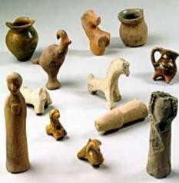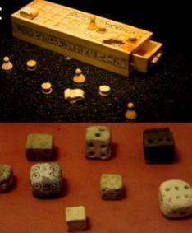

|  |  |
| --- | --- |
| **Overview** | |
| **Toys** are objects that we play with.  Toys can be anything from **simple pieces of wood** and string, to modern **computers and consoles.**  Civilisations from **all points in time**, from way back in history, and from **all around the world**, produced and played with different kinds of toys.  Toys have **developed and changed** a lot over time, as new materials have been used and new technologies have become available.  Many toys, for example dolls, have been around for **hundreds of years**, but the way that they look and have been made have **changed lots over time!** |  |

|  |  |  |  |
| --- | --- | --- | --- |
| **Toys through Time** | | | |
|  |  | -Toys were mostly carved from stone, as humans did not know how to use other materials yet. | **Key Vocabulary**  Toy Console Batteries Electronic Cog Lever Axis Factory Museum  Entertainment Figurine Pulley |
| **Ancient Toys** | -Using stone, craftsmen were able to make items such as dice and dolls. |
|  | -As bronze and iron were used, people began to make toys out of metal. |
| **Toys in the Middle Ages** |  | -Toys were often carved out of wood throughout the middle ages.  -Sometimes, children made their own toys, such as swords made out of sticks and boats made out of hollowed loaves of bread. |
|  | Image result for victorian toys | -Rich girls played with dolls and teas sets, and rich boys played with toy soldiers and marbles. |
| **Victorian Toys** | -Poor families did not have enough money for toys, so made their own. It was before electricity  was widely used, so pulleys, cogs and levers were so users could make toys move. |
|  | Image result for modern toys | -Modern toys have changed rapidly, as different materials and technologies have been used. |
| **Modern Toys** | -For example, remote control cars became popular after batteries were invented and video games consoles became popular after computers were invented. |

|  |  |
| --- | --- |
| **Popular Toys** | |
| **Dolls**  -A doll is a model of a human.  -The earliest dolls can be traced back to the early civilisations of Egypt, Greece and Rome.  -With new materials such as plastic, there are now thousands of different types of dolls that are mass-produced. | **Board Games**  -A board game is a game that is played on a flat surface.  -It involves counter pieces  being moved around on a ‘board.’  -They have been played from the earliest civilisations, e.g. Egypt and Mesopotamia. |
| **Physical Activity Toys**  -These are toys that require the user to be active, e.g. trampolines and hula-hoops.  -Some of these toys, e.g. skipping ropes and balls, have been around for hundreds of years!  -These toys can be used to build up physical fitness. | **Teddy Bears**  -A teddy bear is a soft toy in the form of a bear.  -The first teddy bears were sold in  1992 – named after Theodore ‘Teddy’ Roosevelt.  -There are now thousands of types of teddies. |
| **Construction Toys**  - Construction toys allow the user to build using blocks or pieces.  -The most famous example is Lego, which was first released in Denmark in 1949.  -Over 600 billion Lego parts have been produced! | **Computer Games Consoles**  -A video games console is a computer system on which the user can play games.  -The first games consoles were around from the 1970s, but were nothing like games consoles today! The biggest selling console of all time is the PS2. |

|  |  |
| --- | --- |
| **Top 10 Toys Facts!** | |
| 1. Before electric toys were invented, many toys had levers, hinges and wheels, so that the user could move them. 2. The word ‘toy’ comes from the Old English word meaning ‘tool.’ 3. You can often tell when a toy is from by the material that it is made from. 4. Toys changed a lot after TV was invented: many were based on TV shows that children watch – this still happens today! 5. Rubik’s Cubes are a popular puzzle toy – more than 350 million have been sold! | 1. Toys can be very big or very small – from tiny finger puppets to huge dollhouses! 2. Even a piece of string can be used as a toy! When both ends are tied together, people have used it over the years to play Cat’s Cradle. 3. Sometimes toys go through a ‘craze’ period when they are popular – like the hula hoop in the 1950s or rollerblades in the 1990s. 4. The first ever video arcade game was called ‘Pong’ and was made by Atari in 1972. 5. It takes 63 feet of wire to make a slinky toy. |