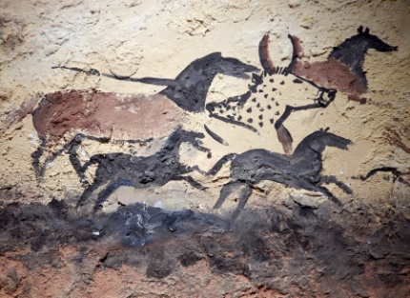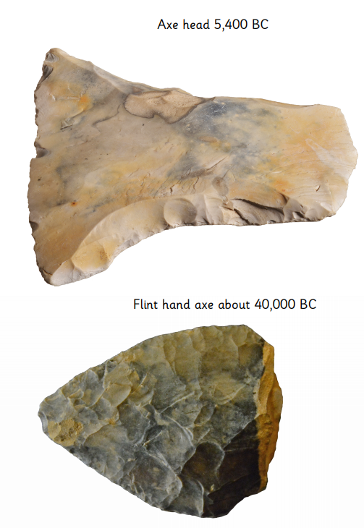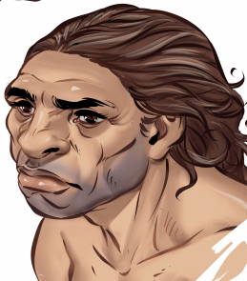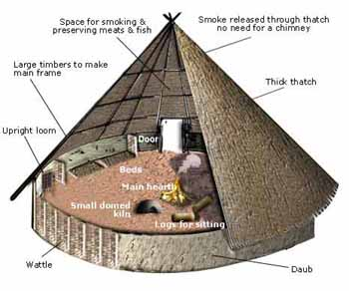

The Stone Age is sectioned into three parts; Palaeolithic (“old”), Mesolithic (“middle”) and Neolithic (“new”).

Early humans were hunter-gathers, and developed into farmers with tools and livestock.

Archaeology can tell us about the past, including how people used to live, beliefs, ceremonies and use of tools.

During the Iron Age, humans lived in tribes and built forts on hills for safety.

**Stone Age to Iron Age**

In the Stone Age, humans began using stone tools. After around 10,000 years, they used metal tools (Bronze and Iron Age).

Cave paintings from the Stone Age tells us about the past, including animals that existed and how people hunted