Celtic families lived together in roundhouses like this. They had thatched roofs and wooden and mud walls with a fire in the centre where they did their cooking

Archaeologists dig up artefacts (objects) from the past and use them to find out about them and the people who owned them.

Then we can learn about the past too.

**My Knowledge Organiser – Romans Year 3**

**Vocabulary**

|  |  |
| --- | --- |
| Archaeologist | A scientist who digs up artefacts from the past and uses them to learn about the past |
| BC/BCE | Before Christ/ Before the Common Era. The time before Jesus was born |
| AD /CE | Anno Domini/The Common Era. The time after Jesus was born |
| Ancient | Very old, historical |
| Century | A period of time – 100 years |
| Invasion | When non-native people come to another country to take over power and rule |
| Conquer | After an invasion when the invaders beat the native people and take over ruling them by force |
| Native | The original or first people to live in a place |
| Empire | The whole of the lands that the Romans conquered and rules over |
| Emperor | The leader of the Roman Empire |
| Timeline | A line that clearly shows events that happened in the past in the order they happened |
| Celt | The name we give to the people who lived in Britain and some parts of Europe at the time the Romans invaded |
| Iron Age | The name we give to the period of time when people lived in the past who were good at mining, working with and using iron |
| Source of evidence | Something we can use from the past that helps us learn about that time |

Archaeologists

It is only because of the work of archaeologists that we know about the past.

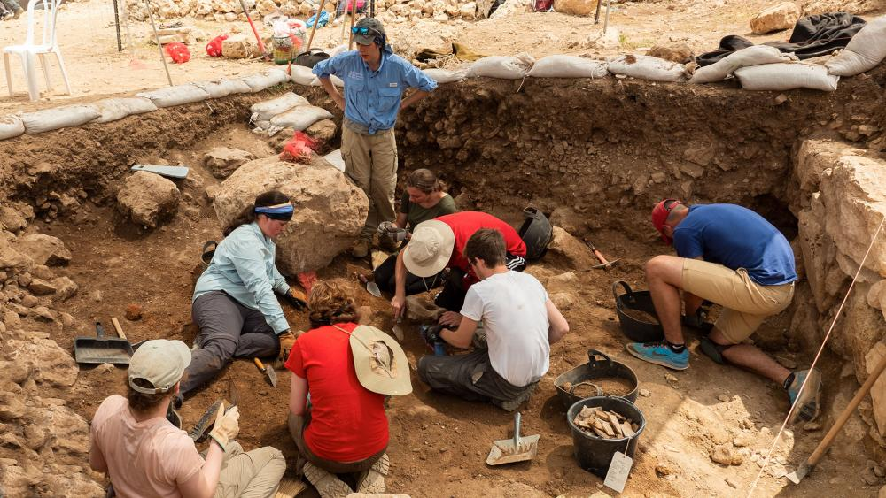

The Iron Age

The people who lived in Britain when the Romans invaded were called the Celts. They were Iron Age people. They lived in small groups and were very good farmers and hunters. They used iron tools, pots and weapons.

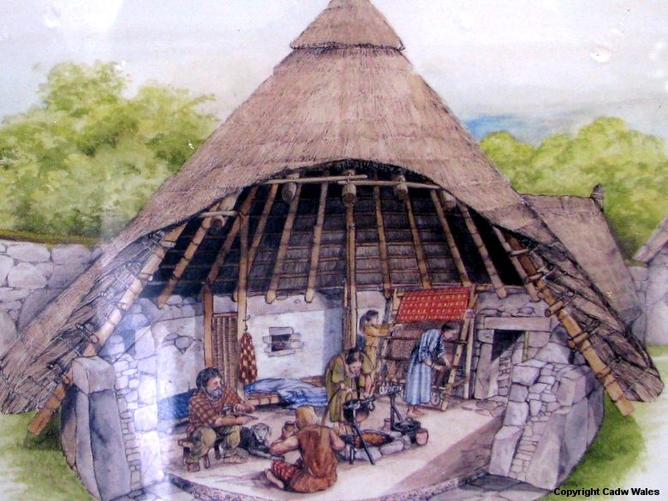

Some Celts paid the Romans taxes to keep them away from their villages.

Some Celts fought back. Boudicca was a Celtic Queen and she gathered an army and fought back fiercely against the Romans.

This timeline shows that the Romans invaded Britain several times, under different emperors, but that they eventually left after nearly 400 years

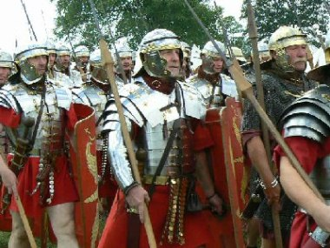

Invaders

Many different groups of people

have invaded Britain.

The Romans came about 2000 years ago

and stayed for about 400 years

The Roman Army was well equipped,

well trained and powerful.

What happened in the invasions?

The Roman army was skilful and very well-trained. They had strong armour and good weapons. They invaded and took over many countries in Europe including Britain. The Roman army was fierce and brutal and defeated many of the Celts.

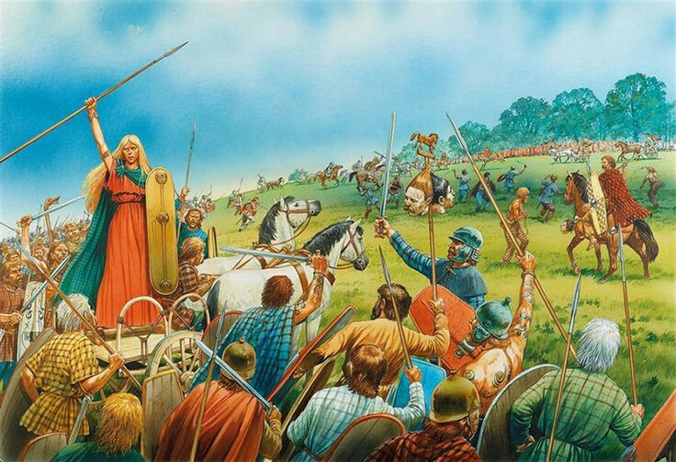

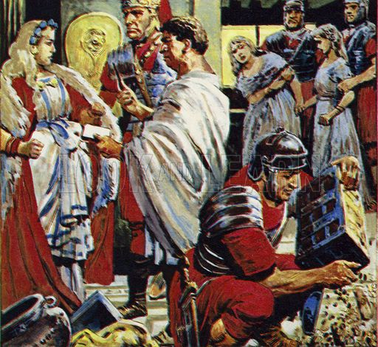

Some Celts and Romans were friendly to each other and lived and worked side by side.

Timelines

Timelines help us see very clearly what events happened in the past and the order they happened.

