The Indus Valley people built big towns and cities on the banks of the River Indus.

They were farmers and used the river to provide water for their crops and everyday life.

Archaeologists dig up artefacts (objects) from the past and use them to find out about them and the people who owned them.

Then we can learn about the past too.

**My Knowledge Organiser – The Indus Valley Year 3**

**Vocabulary**

|  |  |
| --- | --- |
| Archaeologist | A scientist who digs up artefacts from the past and uses them to learn about the past |
| BC/BCE | Before Christ/ Before the Common Era. The time before Jesus was born |
| AD /CE | Anno Domini/The Common Era. The time after Jesus was born |
| Ancient | Very old, historical |
| Century | A period of time – 100 years |
| Civilisation | The way of life or a large group of people which is often more advanced than expected |
| Conquer | After an invasion when the invaders beat the native people and take over ruling them by force |
| Native | The original or first people to live in a place |
| Empire | The whole of the lands that a group of people have conquered and rule over |
| Emperor | The leader of the Empire |
| Timeline | A line that clearly shows events that happened in the past in the order they happened |
| Source of evidence | Something we can use from the past that helps us learn about that time |

Archaeologists

It is only because of the work of archaeologists that we know about the past.

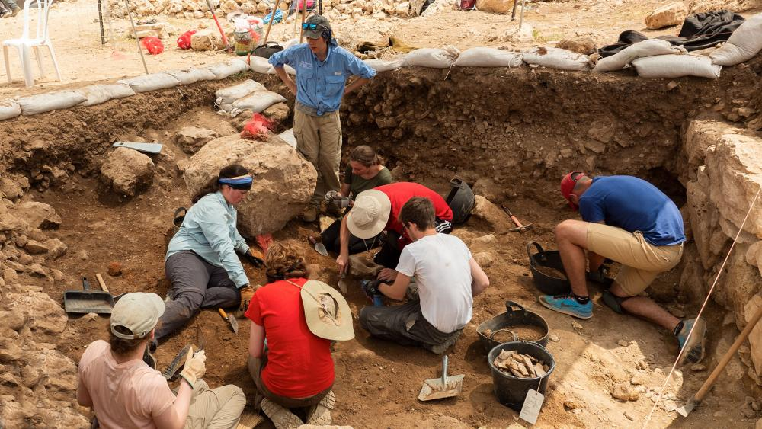

The Indus Valley People

The people who lived in The Indus valley lived about 5000 years ago. They were part of the Bronze Age people. They lived where Pakistan and Northern India are today.

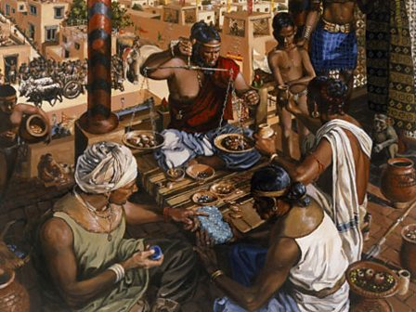

This timeline shows when the Civilisation of the Indus Valley people began and ended.

All the events happened BC

The cities had high walls around them and had wide streets for horse and carts or elephants to pass along them

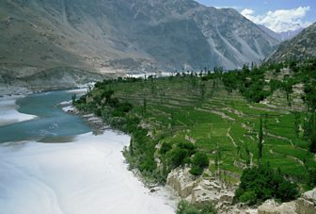

Where is the Indus Valley?

The Indus is the longest river in Pakistan.

It begins in the Himalayas and flows down

to the Arabian Sea.

The Indus people called the river

The King River

because it was so important to them.

Towns and Cities

The Indus Valley people were very skilled builders and they built town and cities which were neat and well planned. They had straight roads and drains to take away rubbish.

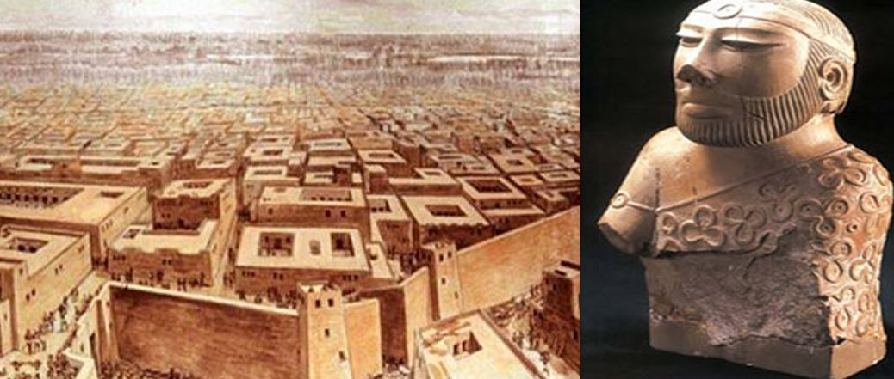

Everyday Life

People in the Indus Valley spent a lot of time outside as it was very hot. They would cook and play and sometimes sleep outside on their flat roofs.

Children often kept pets and played games just like children do nowadays.

Adults didn’t use money but they would trade goods they had for other goods that they wanted or needed.

Timelines

Timelines help us see very clearly what events happened in the past and the order they happened.

