The Aboriginals and Torres Strait Islanders were the very first people who settled and lived in the land we now call Australia.

They came about 30-40000 years ago.

They were nomadic hunter gatherers. This means they got their food from the land around them. Many of them still try to live like this.

**My Knowledge Organiser; The History of the Aboriginal People Year 3**

**Key vocabulary**

|  |  |
| --- | --- |
| BC or BCE | The time before Jesus Christ was born or Before the Common Era |
| AD or CE | Anno Domini – The time after Jesus Christ was born or The Common Era |
| Century | A period of time – 100 years. We use the century to give an idea of when things happened in the past |
| Ancient | A word to describe something that is very old |
| Archaeologist | A person who finds out about the past using real objects found |
| Continent | There are 7 continents in the world and each one is made up of several countries |
| Country | A country is a place that has its own government and laws. It may have its own language, traditions and way of life. |
| Nomad | A person who does not settle and live in one place but travels around living off the land |
| Ancestor | A person in your family who lived before you, recently or many years ago. |
| Dreamtime | The time for the Aboriginal People when they world and all that is in it was being created |

Who were the Aboriginal People?

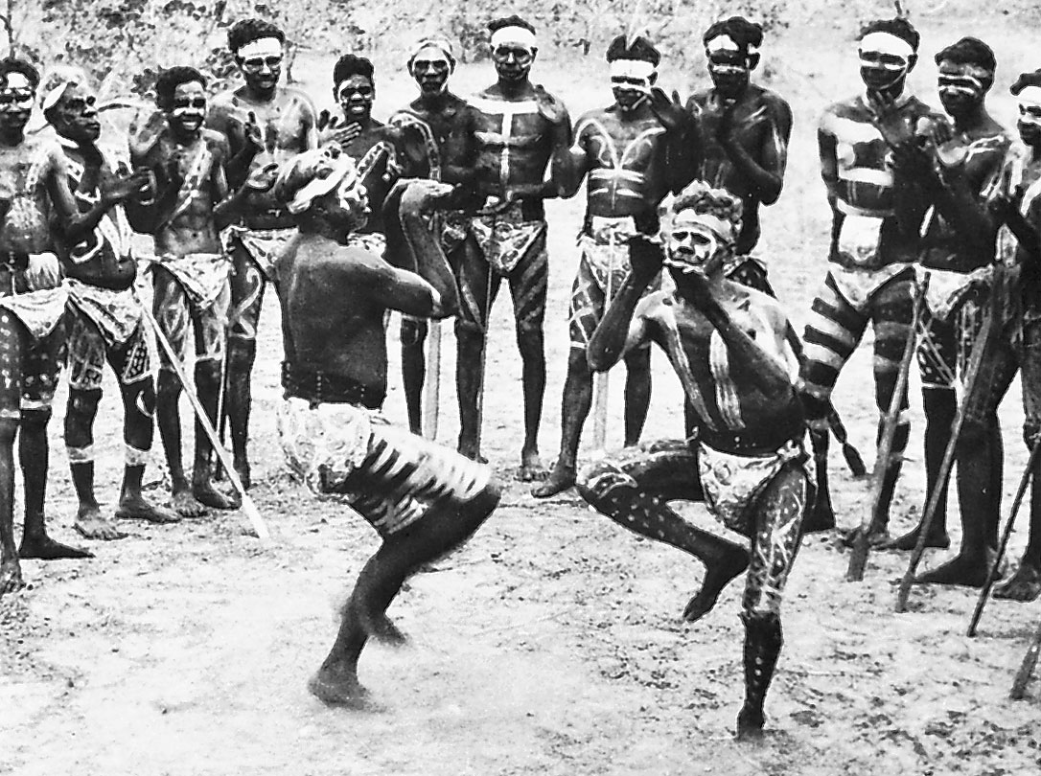

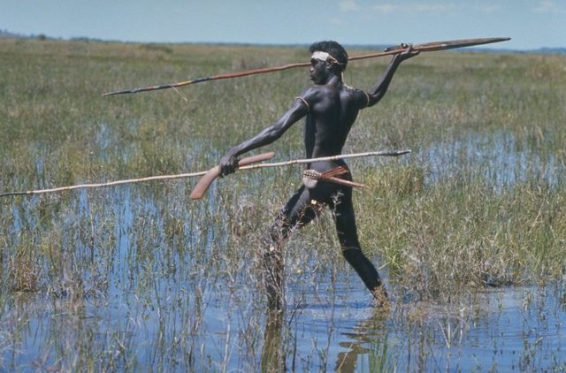

What are the Aboriginal People Like?

The Aboriginal and Torres Strait Islanders have lots of special traditions. They tell many stories about their history and their ancestors and call these stories the Dreamtime.

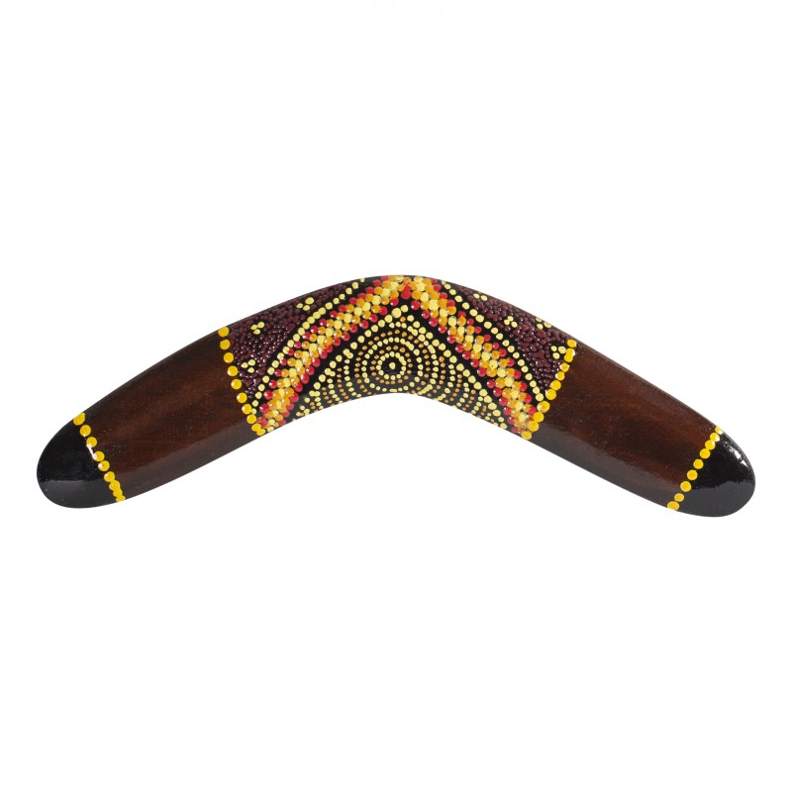

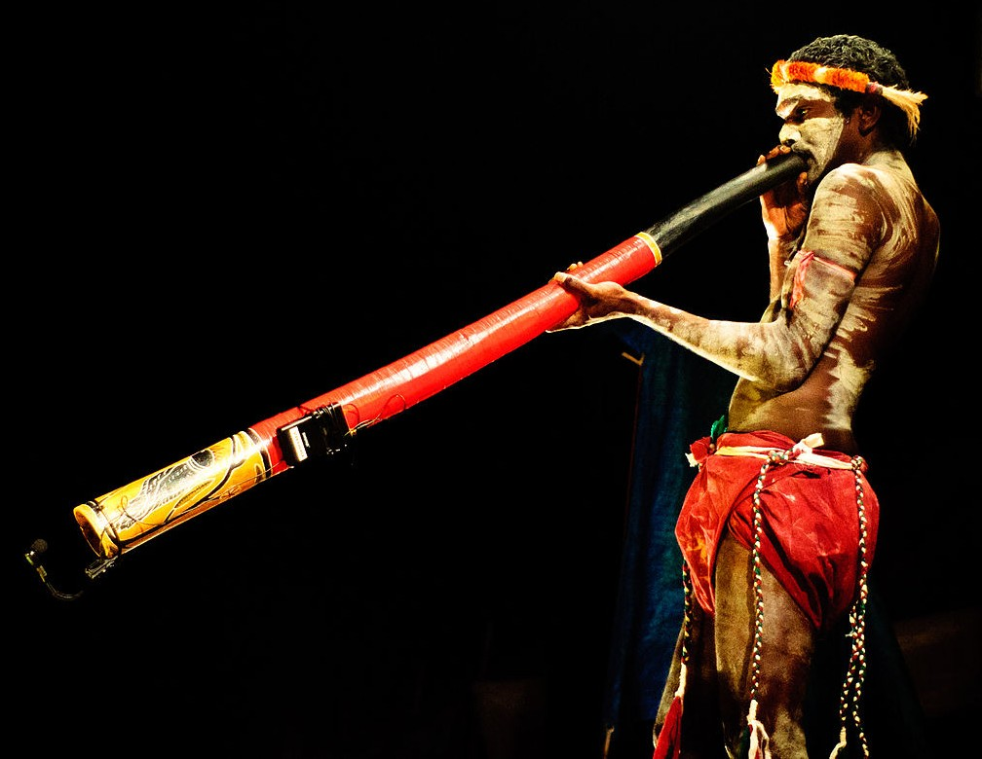

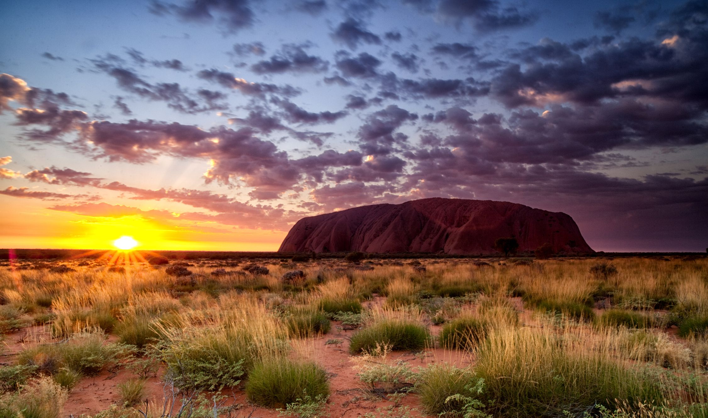

Settlers from Europe

Over the last 300 years many people, mostly from Europe have settled in Australia.

Some of them treated the native Aboriginals very badly.

They took their land without asking.

They also came with diseases which were new to the Aboriginals and often killed them.

Now, people in Australian try to respect the native people and live side by side with them

The Aboriginals were very good at living in the Australian Outback. They could hunt, find food and water and they loved their land

They played traditional music on a long instrument, made from a branch, called a Didgeridoo

They were, and some still are, skilful hunters and used a special weapon called a Boomerang