|  |  |
| --- | --- |
| **Key Facts** | |
| **Why was William I known as William the Conqueror?** | William I came from France. He killed King Harold in 1066 and took over England, becoming known as ‘William the Conqueror’. A conqueror is someone who gains something by force. |
| **Why was King Edward I known as ‘Longshanks’?** | King Edward I was given the nickname ‘Longshanks’ because he was very tall. He was also called the ‘Hammer of the Scots’ as he spent years fighting wars with Scotland. |
| **What is Henry VIII known for?** | Henry was desperate for a son, so when his wife Katherine of Aragon gave birth to a baby girl, he divorced her. In doing so, he split England from the Catholic Church and created the Church of England.  Henry had a total of six wives. He divorced two and beheaded two! |
| **Who is the longest reigning monarch?** | In 2015, Queen Elizabeth II became the longest reigning monarch with 65 years on the throne. Before this, Queen Victoria had been the longest reigning monarch. |
| **What is Richard III remembered for?** | Richard III is often remembered for being a cruel and unkind king. Some people think he killed his nephews to become king. He is also famous because nobody knew where he was buried until his skeleton was discovered in a car park in 2012. |
| **Who was Elizabeth I?** | Elizabeth I was the daughter of Henry VIII.  She never married, although she said she was married to her country. |

# Significant Kings and Queens Timeline

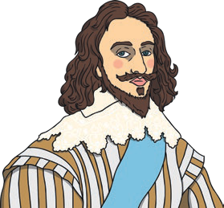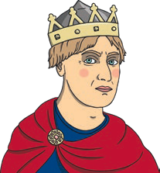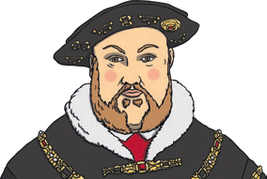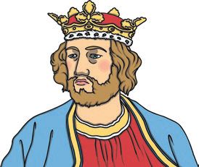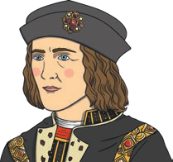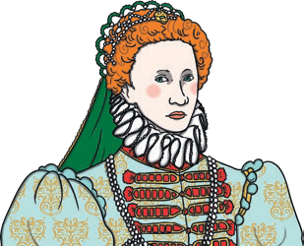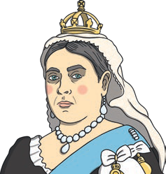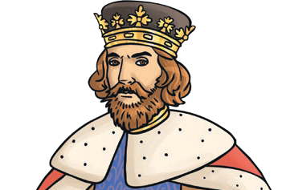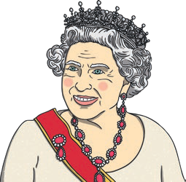

**1952-present**

Queen Elizabeth II

**1199-1216**

King John

**1625-1649**

King Charles I

**1272-1307**

King Edward I

**1837-1901**

Queen Victoria

**1066-1087**

William the Conqueror

**1558-1603**

Queen Elizabeth I

**1509-1547**

Henry VIII

**1483-1485**

King Richard III

**since 1066**

|  |  |
| --- | --- |
| **Key Vocabulary** | |
| **monarch** | A monarch is a king or queen, an emperor or a sultan. |
| **Parliament** | This is where politicians meet to decide laws. |
| **succession** | This is the order in which a monarch’s family will take over the throne. |

|  |  |  |  |  |  |  |  |
| --- | --- | --- | --- | --- | --- | --- | --- |
| **Key People** | | | | | | | |
| **William the Conqueror**  **Charles I** | **Edward I** | **Henry VIII** | **Elizabeth I** | **Richard III** | **Victoria** | **John** | **Elizabeth II** |