Research the life of a famous inventors from the past using different resources to help them | Explain why Britain has a special history by naming some famous people e.g. Guglielmo Marconi and Charles Macintosh | Use historical words and phrases: before I was born, many years ago, before, after, past, present, then, now
Ask questions about famous people and find the answers by using a specific sources, such as, an information book/page or the internet | Famous Inventors:  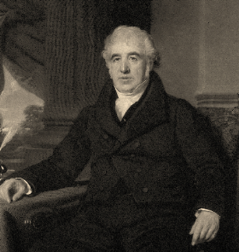  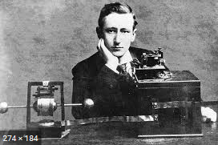  Marconi and Macintosh | Give examples of things that are different in their life from that of a long time ago
Say at least two ways they can find out about the past | Say why these inventors are famous and what they are famous for inventing | Sequence a set of objects in chronological order e.g. order when a set of items were invented

