**The British Empire**

|  |  |
| --- | --- |
| **Key vocabulary** | **Definition** |
| empire | An empire is a group of countries ruled over by a single monarch or ruler. |
| imperial | Belonging or relating to an empire. |
| colony | A country or area controlled by another country that is often far away. |
| commonwealth | A group of nations with a shared loyalty or government. |
| trade | Buying, selling or exchanging goods between people, companies or countries. |
| slave | A person who is owned by another person and has to obey them. |
| merchant | A person involved in trading goods. |
| convict | Someone guilty of committing a criminal offence. |
| penal | Relating to a punishment for breaking the law. |
| rebellion | An act of armed resistance to an established government or leader. |
| mutiny | Refusal to obey orders or an attempt to take control from those in authority. |
| Raj | The period of British rule in India after 1857. From the Hindi word for reign. |
| East India Company | Trading company that gradually took control of India |
| empress | A woman of great power, who rules an empire. |

# The British Empire

At its largest, it covered 13 million miles or about 25% of the world.

It controlled over 450 million people or 20% of the world’s population.

# Controlling the Empire

Military Force – Britain developed new weapons were invented weapons and also stopped guns coming into the hands of those in the Empire.

Use of Locals – The British went on a charm offensive, making the local rich people feel wanted and gave them more money and power. Local people ran the police, law courts and prisons, making them feel in charge of their country and less likely to break laws.

Communication – The British could easily communicate between the countries of their empire using methods such as telegraphs, radios and ships.

Gradual Change – The British didn’t try to change everything at once, they gradually changed and developed areas of countries.

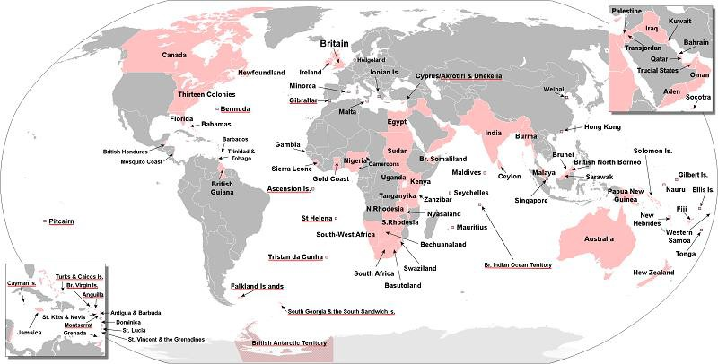Dealing with Resistance – The British were efficient in stopping anyone who opposed the Empire. Protestors were immediately jailed and they broke up local armies.

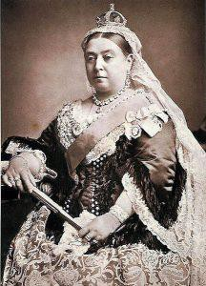

# Queen Victoria – Ruler of the British Empire