**Key Terms Key concepts**

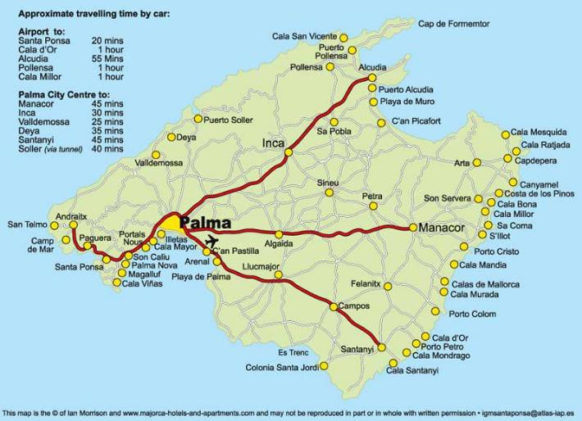

**Example of Impact of Tourism**

**Tourism**

## Tourism

**National parks**

**Small scale tourism e.g. Ecotourism**

**Sustainable management**

**Honeypot site**

**Mallorca Conflict**

People visiting places of interest on holiday

National parks are **large areas** of **beautiful** countryside

The scenery and wildlife are **protected** so that everyone can enjoy them

Responsible travel to natural areas that protects the environment

Management of an area that preserves the environment, the needs of present and future generations and the economy.

a **location** attracting a large number of tourists who, due to their numbers, place pressure on the environment and local people.

An Spanish Island located in the Mediterranean Sea

when there is a disagreement between two or more people over how something should be used or done. (difference of opinions

# Tourism is a massive part of the world’s economy.

Tourism has been increasing due to many reasons.

There are 15 national parks in Britain

National Parks vary but all have the same three aims:

|  |  |
| --- | --- |
| **Mallorca** | |
| Mallorca is located in the Balearic islands. It is an island near the coast of Spain and is located in the Mediterranean sea. Palma is the capital. | |
| Positives | Negatives |
| * Tourists spend money on attractions, food and drink or souvenirs. This money boosts local economy * Tourism brings a variety of jobs such as waiters, cleaners, chefs, receptionists etc. * Money spend can be used to improve the local facilities . | * Tourist may not respect the area and choose to litter and behave in an anti- social way such as being drunk and loud or fighting. * More tourists means that more tourist facilities are needed therefore high rise concrete buildings are built and spoil the view. |

-To preserve and care for the environment

-To provide a place for recreation and

enjoyment

-Wellbeing of the locals

|  |
| --- |
| **Reasons for growth of tourism** |
| Introduction of paid holidays |
| More disposable income |
| Easier to book holidays with introduction of the internet |
| Better transport structure (aeroplanes) |
| Package holidays introduced |