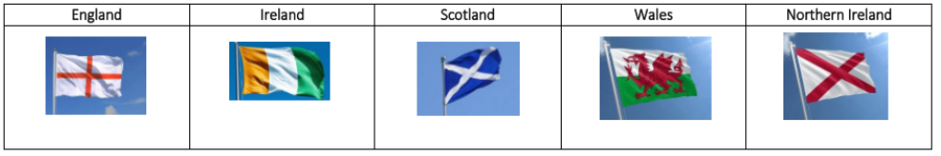

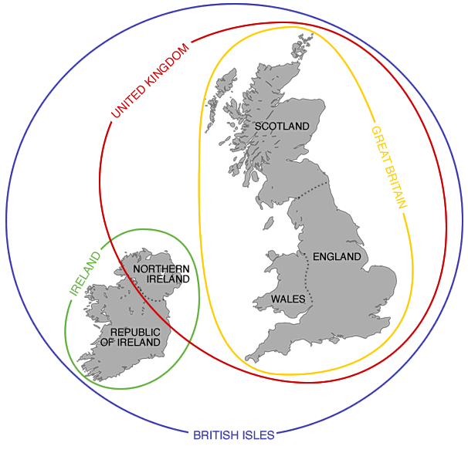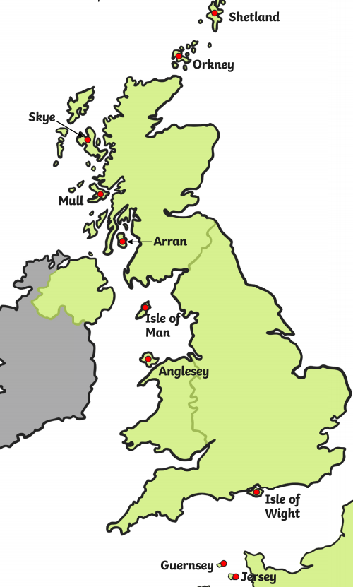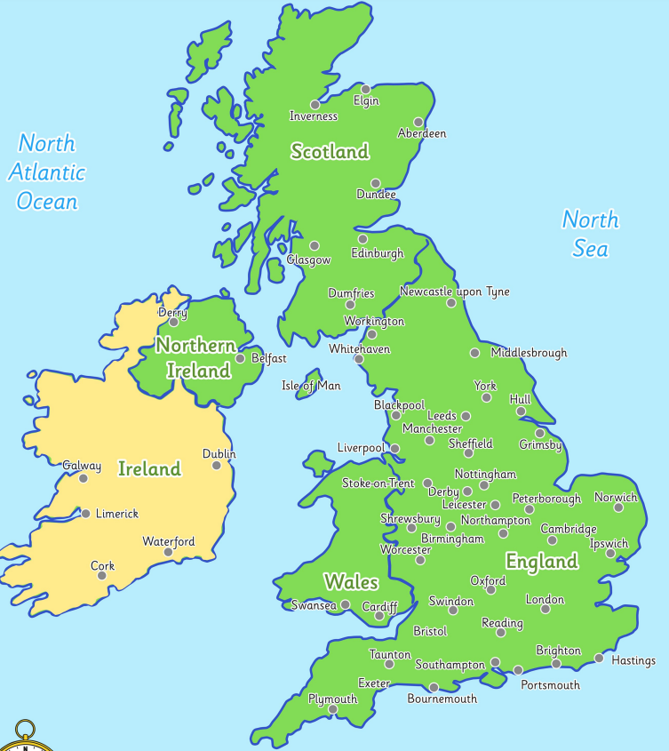Cities Islands of the British Isles Great Britain, the UK, and the British Isles

**Home Counties of London**

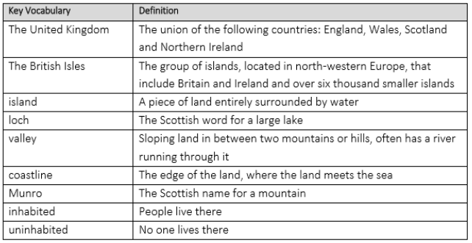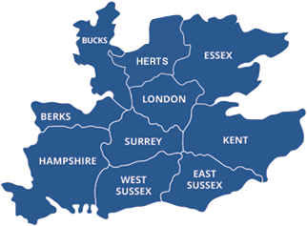

**Tropic of Cancer and Capricorn**

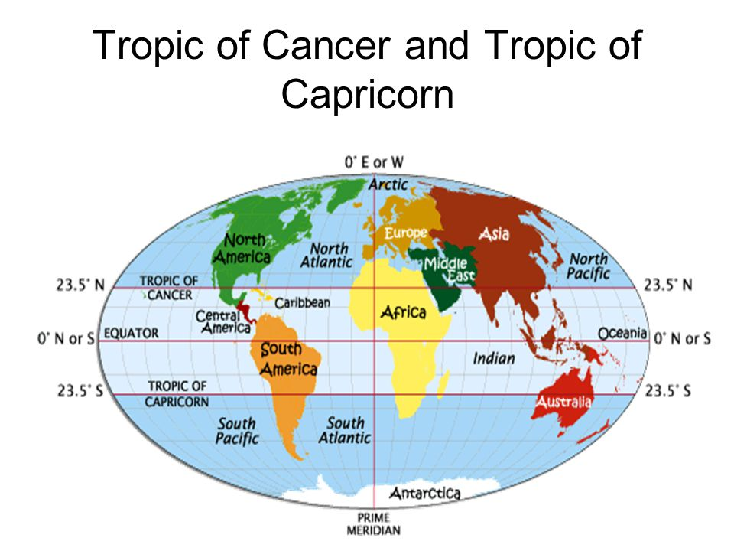

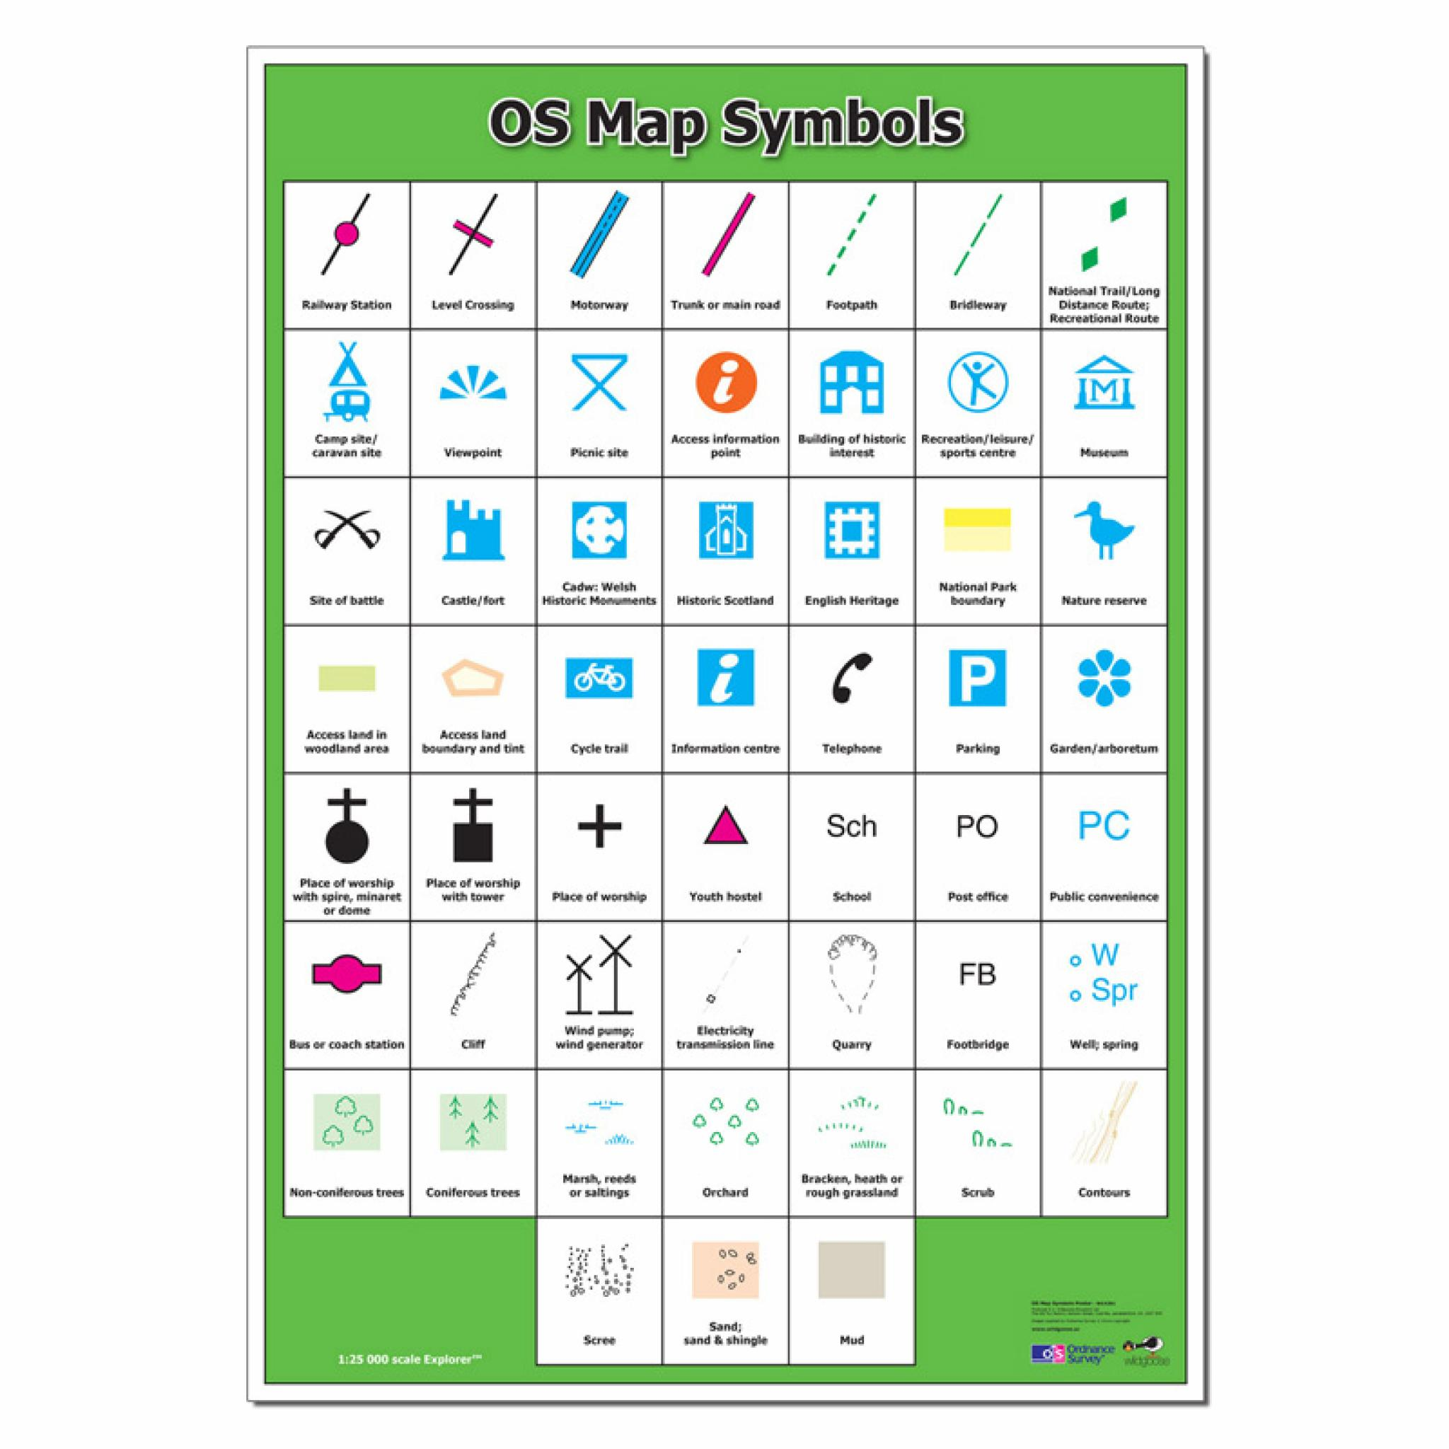**Reading maps**

|  |  |  |  |
| --- | --- | --- | --- |
| **UK Human Features** | | **UK Physical Features** | |
| **Population densities**: Av. 259 people per square kilometre; most dense in southeast with one third of the population. |  | **Natural Resources:** Oil and natural gas produced; coal deposits; 75% of land suitable for farming | Coal Oil And Gas Clipart |
| **Ethnic groups:** Migration from all over world; much ancestry from European Mainland (e.g. Anglo Saxons, Vikings and Romans) | Population Year 2018 | Worldmapper | **National Parks**: The Peak District; The Lake District | 15 Best National Parks in Britain |
| **The Monarchy**: Queen Elizabeth II and Prince Phillip; Prince of Wales and Duchess of Cornwall; Duke and Duchess of Cambridge | Clipart Crown Purple - Queen Crown Png Clipart, Transparent Png ... | **Climate and Weather:** Overcast skies; south brighter and drier than the north; warm air arrives via Gulf Stream | Partly covered cartoon sun with rain clouds icon Vector Image |
| **Sports/ Recreation**; Wembley Stadium, Wimbledon Tennis | Cartoon Sport Clipart | **Mountains**: Ben Nevis; Mount Snowdon | grough — 'Extremely lucky' walkers rescued from icy Ben Nevis in ... |
| **Historical Landmarks**: Stone Henge; Edinburgh Castle; Colchester Castle | Stonehenge | English Heritage | **Topography:** North and west are highlands; east and south are lowlands | Ian B on the Bases of Scottish Separatism | The Ludwig von Mises ... |
| **Tourist attractions**: London Eye; The Angel of the North; Roman Baths; The Eden Project. | London Eye - Wikipedia | **Coastline / beaches**: Cornwall; Durdle Door on the Jurassic Coast | 9 of the best coastal cottages in the UK | London Evening Standard |
| **Government**: Democracy; Houses of Parliament | Houses of Parliament (Westminster) Tour - London Top Sights Tours | **Rivers and Lakes**: River Trent; Loch Ness | Royal Geographical Society - Geography resources for teachers |