Seasonal and Daily Weather
What should I already know? |  | Diagrams | What will I know by the end of the unit?
- The country I live in in England  - Where the United Kingdom is and locate it on a map.  - There are different types of weather. |  | 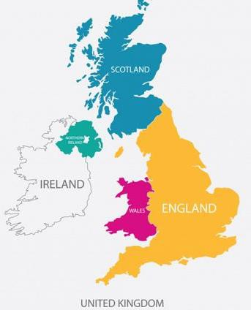  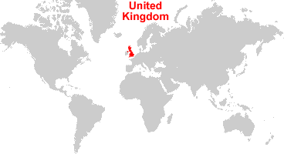  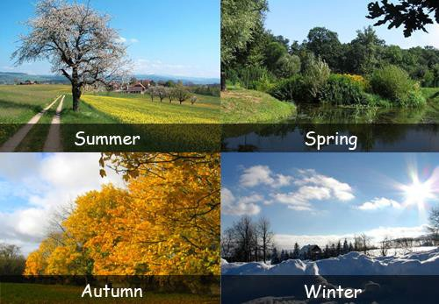 | - There are 4 seasons.  - The weather patterns are different in each season.  - A weather forecast is a statement saying what the weather will be like today, the next day or for the next few days.  - Weather forecasts use different symbols which are helpful.    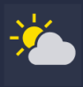        - When the weather changes, you need to wear the correct clothes and do different activities.  - You can record the temperature using a thermometer to see how warm or cold it is.
Key vocabulary
Weather | The state of the atmosphere at a particular  place and time.
Seasons | Each of the 4 divisions of the year
Spring | The season after winter and before  summer.
Summer | The season after spring and before  autumn.
Autumn | The season after summer and before  winter.
Winter | The season after autumn and before  spring.
Weather forecast | A statement saying what the weather will be like today, the next day or for the next  few days.
Rain | Water the falls from clouds in small drops.
Sun | A star that provides light and heat to the  Earth.
Wind | A current of air moving across the Earth’s  surface.
Thunder | A sudden loud noise that comes from the  sky during a storm.
Snow | The small, soft, white pieces of ice that  sometimes fall from the sky when it is cold.
Cloudy | When the sky is full of clouds which make  it seem darker.
thermometer | A device used for measuring temperature.
temperature | The measured amount of heat in a place.
United Kingdom | a country that includes England, Scotland, Wales and Northern Island
Spring | March, April, May
Summer | June, July, August
Autumn | September, October, November
Winter | December, January, February

Sunny
Sunshine with cloud
Cloudy
Raining
Thunder
Windy
Snow

