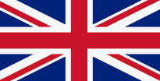

KNOWLEDGE ORGANISER

**LONDON**

|  |  |  |  |  |  |  |  |
| --- | --- | --- | --- | --- | --- | --- | --- |
| **Overview** | |  | **Human Geography Features** | | | | |
| -London is the capital city (and the largest city) of both England and the United Kingdom.  -London has been a major settlement for around two millenniums – it was founded by the Romans.  -It was originally called Londinium.  -London is a very large city, with around 9 million people living in it (14 million if you include its wider metropolitan area).  -It is considered to be one of the most important global cities, being a major commercial, tourist, banking and education centre. | |  | Population Densities |  | In the UK, London is the city with the most people by far. There are 1,510 people per sq. km (population density). Greater London has the densest population in the UK. | Key Vocabulary  City  Capital  Population Density  Ethnicity  Industrial Revolution  Commercial  Tourism  Recreation  Parliament | |
| Ethnic Groups |  | London is one of the most ethnically-diverse cities in the world – people of many different cultures live in the city. Only 44.9% of people in London are White British. |
|  | The Monarchy |  | London has been the capital city of England since the 12th Century, and of the UK since 1801. Buckingham Palace has housed the monarchy since 1837. |
| Industrial Revolution |  | London was perhaps the first major city affected by the industrial revolution. The rise of machines in production, the use of natural resources like oil and coal, and the construction of better roads and buildings, turned London into the world’s first megacity. London was the world’s most populated city between 1831 and 1925. |
|  |  |  |
| **Places in London** | |  |
| Most Populated London Boroughs   1. Barnet – 392,000 people 2. Croydon – 385,000 people 3. Newham – 352,000 people 4. Ealing – 342,000 people 5. Enfield – 334,000 people   Biggest Boroughs (area)   1. Bromley – 150.1 km² 2. Hillingdon – 115.7 km² 3. Havering – 112.3 km² 4. Croydon – 88 km² 5. Barnet – 86.7 km²   London is current split into 32 Boroughs – plus the City of London. The London Boroughs were created on 1st April 1965. | |  |  |  |  |  |  |
| **Physical Geography Features** | | | | |
| The River Thames |  | The River Thames is the longest river entirely in England, at 215 miles long. London is based at the head of its 50-mile estuary leading to the North Sea. The Romans originally formed ‘Londinium’ in about 47CE, using the river as a valuable trade route. It continues to be a vital waterway for South-east UK today. | Key Vocabulary  Resources  Settlement  River/ Estuary  Flood Plain  Low-Lying Land  Climate  Temperate  Maritime  Greenwich Meridian | |
|  |
| Tower of London  The Tower of London is a historic castle based on the north side of the River Thames in central London. It was founded in 1066 after the Norman Conquest. It was used as a prison from 1100 until 1952. It also where the Crown Jewels are kept. | Big Ben  Big Ben is the bell situated in the clock tower at the north end of the Palace of Westminster. When the clock was built in 1859, it was the largest chiming clock in the world. It is now a British cultural icon that is recognised all over the world. |  |
| Climate and Weather |  | London has a temperate maritime climate, meaning that it has cool summers and mild winters. It receives less rain than Rome or Sydney! The temperature averages 23°C in the summer and 8°C in the winter. |
| **Buckingham Palace**  Buckingham Palace is the London residence of the monarch (King or Queen) of England. Elizabeth II currently lives in the palace. The building has existed since 1703. The palace has 775 rooms and the garden is the largest private garden in London. | St. Paul’s Cathedral  St. Paul’s cathedral is in the City of London. The old version of the cathedral, built 1310, was the tallest building in the world until 1311. It was destroyed in the 1666 Great Fire of London and was rebuilt, designed by Christopher Wren. |  | Fauna |  | London has 40% green space and open water, with 2000 species of flowering plant. The Thames has about 120 species of fish. About 10,000 red foxes live in London. |
|  |
|  | Greenwich Meridian |  | Because of Britain’s position as an advanced maritime nation in past, Greenwich, London was chosen as the location of 0° longitude. The east/west hemispheres are still divided by this point. |

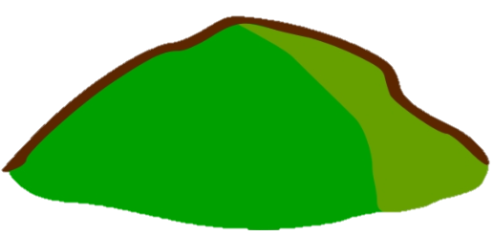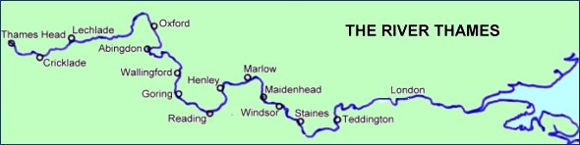

The River Thames

Highest Hills





Highwood Hill – 145m

Arkley – 147m

Big Wood Peak –150m

Stanmore Hill - 152m

– 5,636m

Sanderstead – 175m

Westerham Heights – 245m