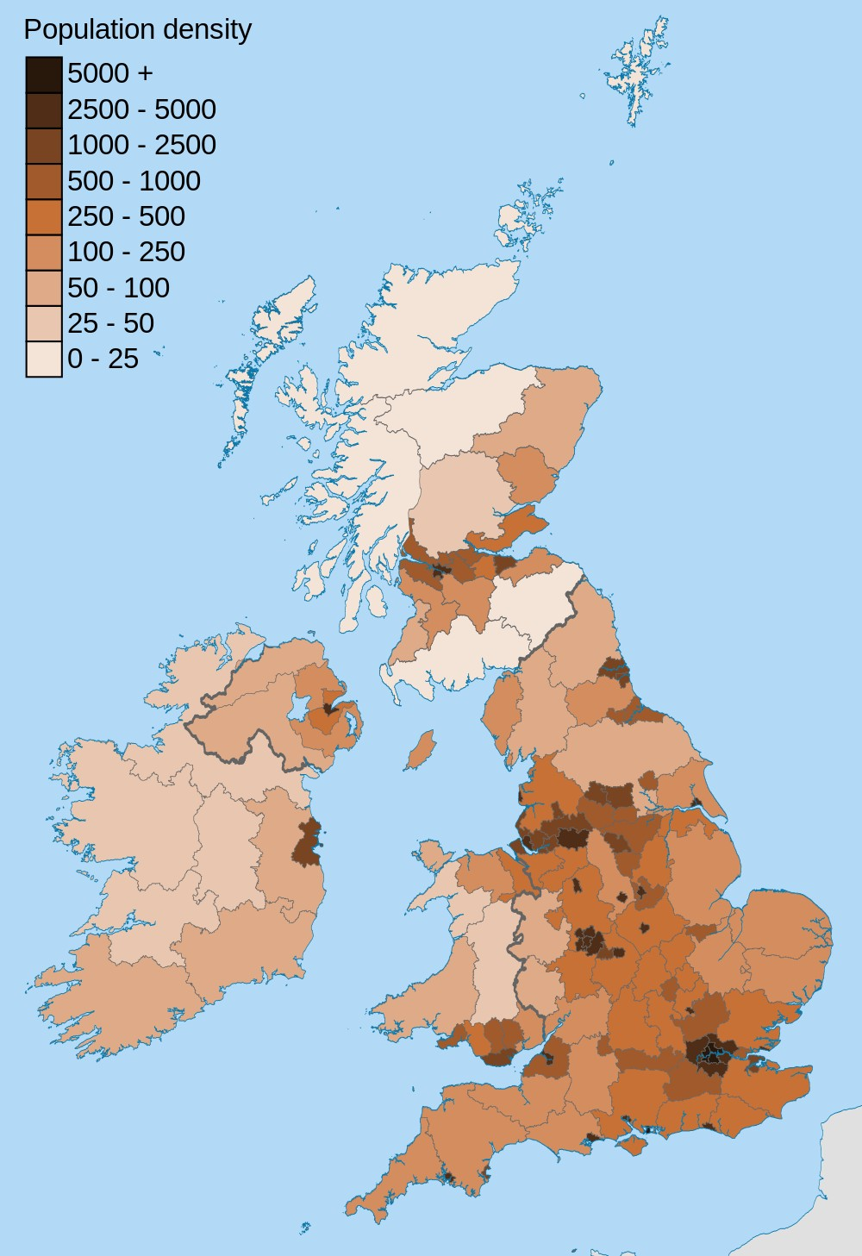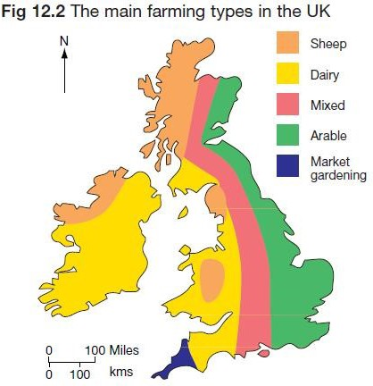

**Land-use Strand: Locational Knowledge / Human and Physical Geography**

## What should I already know?

* The **city** I live in is called Chelmsford, which is in Essex. There are **villages** and **towns** in Essex, some of which are **coastal**.
* Essex is a **county** in England and is famous for

**agriculture/farming**.

* England, which is a **country** in the United Kingdom, is in the **continent** of Europe.
* The **human** and **physical geographical** features of Chelmsford and know it looks on a map.
* Know why groups of people settle in certain areas.
* Be a **cartographer!** Sketch maps of Chelmsford, includ- ing the school, the River Chelmer and the River Can and Wid
* Compare your map to an Ordnance Survey map of Chelmsford. What do you notice? What do the symbols on the Ordnance Survey map mean?
* Use Google Maps to compare land use in Chelmsford, Essex and a **village.** What do you notice? What is the same? What is different?
* Create a **key** using symbols to show what different features are.
* Compare maps of present Chelmsford to maps of

**historical** Chelmsford - how has the use of land changed over time?

* Look at aerial view photographs of the world and identify which places are **urban** and which are **rural**.
* Using **population density maps**, study the **population**

numbers for **urban** and **rural** areas. What do you notice?

* Compare **urban** and **rural** areas using four-figure grid

references.

* Compare maps of different **agricultural** areas and explain why an area is suited to **crop** or **livestock farming**.
* Identify features such as hills, mountains, **coasts** and

**rivers** on a map.

**Geographical Skills and Fieldwork**

**London**

**Diagrams**

**Chelmsford**

|  |  |
| --- | --- |
| **Vocabulary** | |
| agriculture | farming and the methods that are used to raise and  look after crops and animals |
| arable | farming that involves growing **crops** such as wheat and barley rather than keeping animals or growing fruit and  vegetables. |
| cartographer | somebody who draws and produces maps |
| city | a large **town**. London is a **city**. |
| coastal | an area of land close to the sea |
| compass points | any of the [main](https://www.collinsdictionary.com/dictionary/english/main) points of a compass: north, south, east,  west, north-east, north-west, south-east, south-west |
| country | an area of land that is controlled by its own  government. |
| county | a region of Britain or Ireland which has its own local  government |
| crop | plants such as [wheat](https://www.collinsdictionary.com/dictionary/english/wheat) and [potatoes](https://www.collinsdictionary.com/dictionary/english/potato) that are grown in  large quantities for food |
| density | the [extent](https://www.collinsdictionary.com/dictionary/english/extent) to which something is filled or covered with  people or things |
| farming | the activity of growing [**crops**](https://www.collinsdictionary.com/dictionary/english/crop) or keeping animals on a  farm |
| historical | people, [situations,](https://www.collinsdictionary.com/dictionary/english/situation) or things that [existed](https://www.collinsdictionary.com/dictionary/english/exist) in the past |
| human  geography | features of land that have been impacted by human  activity |
| key | The key on a map or diagram is a list of the symbols  used and their meanings |
| landscape | everything you can see when you look across an area of  land, including hills, rivers, buildings, trees, and plants. |
| livestock | animals such as cattle and [sheep](https://www.collinsdictionary.com/dictionary/english/sheep) which are kept on a  farm |
| physical  geography | natural features of land |
| population | all the people who live in a **country** or area |
| present | things and people that exist now |
| rural | places that are [far](https://www.collinsdictionary.com/dictionary/english/far) [away](https://www.collinsdictionary.com/dictionary/english/away) from large **towns** or **cities** |
| town | a large group of houses, shops and buildings where people live and work. **Towns** are larger than **villages** but  smaller than **cities**. Sudbury is a **town**. |
| urban | belonging to, or relating to, a **town** or **city** |
| village | a small group of houses, perhaps with a few shops, that  are often in the countryside. Great Cornard is a **village**. |