|  |  |  |  |
| --- | --- | --- | --- |
| **AUTUMN TERM TOPIC: THE WIZARD OF OZ** | | | |
| **Local Study: Chelmsford** | | **Year 2** | **Geography** |
| **What should I already know?** | |  |  |  |  | | --- | --- | --- | --- | | **Information about Chelmsford** | **Vocabulary** | | | | * Chelmsford is a **city**. * It is near London which is also a **city**. * Chelmsford and has lots of **shops**, **offices** and **houses**. * There are also **factories** in Chelmsford. * The **River** Chelmer runs through Chelmsford. * There is a **market** and **train station** in Chelmsford. | aerial view | a view from above | | | factory | where goods are made in large quantities | | | farm | an area of land used to produce crops or to breed animals  and livestock. | | | hill | a naturally raised area of land, which is not as high as a  mountain. | | | house | a building designed for people to live in. | | | human  geography | features of land that have been impacted by human activity | | | map | a drawing of a particular area such as a city, a country or a | | |  | | **Human Geographical Features** | | market | a place where people gather to buy and sell goods | | |  | office | a building of rooms where business and work is carried out by **office** workers. | | | physical  geography | natural features of land | | | river | a large, natural stream of fresh water that flows into the sea  or a lake. | | | shop | a building in which goods are sold. For example,  supermarkets, clothes shops and toy shops. | | | town | a large group of **houses**, **shops** and buildings where people live and work. **Towns** are larger than **villages** but smaller  than cities. Sudbury is a **town**. | | | Train station | a place on a railway line where trains stop for people to get  on and off trains. | | | village | a small group of **houses**, perhaps with a few shops, that are  often in the countryside. Little Baddow is a **village**. | | | **Physical Geographical Features** |  | | | | **Geographical Skills and Fieldwork** | |  | |  | * Go on a tour of the school using a **map** and then look at an **aerial view**   photograph - can you label it with human and physical features?   * Take a walk around Meadgate using a **map** to help you. What symbols are on the **map**? What do they mean? * Look at an **aerial view** photograph of Meadgate/Chelmsford - can you label it with human and physical features? * Can you draw a simple **map** that includes your **house** and the school. Can you label your **map** or use symbols? * Can you use words like near/far and right/left to describe where places are? * Compare Chelmsford and London using maps/aerial photos. How are they similar? How are they different? | |  | | | |
| * The **city** I live in is called Chelmsford. * Chelmsford is in England. * Chelmsford is near London. |

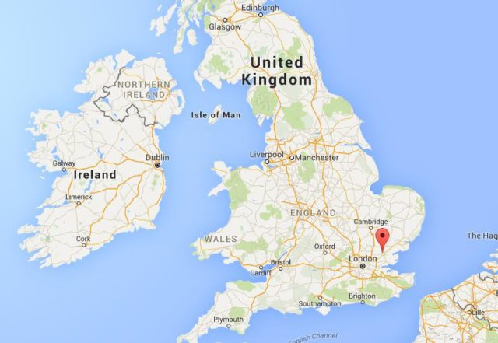

* **shops**:
  + supermarkets
  + chemists
  + fast food outlets
  + motor repair shops
* restaurants
* sports clubs and sports centres
* parks including Central Park
* schools
* houses
* churches
* cathedral
* libraries
* community centres
* farms

**What can I find in Chelmsford?**