The crust of the Earth is not made of one large piece of rock.

It is divided into huge, flat chunks called plates which fit together like a jigsaw.

If you could cut into the Earth, you would see it is made up of these 4 main layers.

The crust is the solid outer layer.

The mantle is partly made up of molten rock.

**My Knowledge Organiser – Mountains and Volcanoes Year 3**

**Vocabulary**

|  |  |
| --- | --- |
| Mountain | A large elevation of rock in the Earth’s surface |
| Volcano | A volcano is a rupture in the Earth’s crust that allows hot lava, ash and gases to escape from the magma chamber under the crust |
| Physical feature | A feature on the Earth that is created naturally. Not man-made |
| Crust | The rocky outer layer of the Earth. The surface |
| Tectonic Plate | The crust of the Earth is not one smooth piece. It is made up of many large rocky parts that fit together like pieces of a jigsaw. They float on the mantle |
| Mantle | The layer beneath the crust of the Earth that is also made of rock. Some of this rock is so hot it has melted – become liquid. |
| Molten | Something so hot it has become a liquid |
| Magma | Molten rock beneath the crust that lies beneath a volcano in a Magma Chamber |
| Lava | The molten rock that has erupted from a volcano. It flows down the side and eventually cools and hardens |
| Eruption | When magma, gases and ash come out of a volcano. Eruptions are often sudden and can be huge and dangerous. |
| Ring of Fire | The name of the circle of volcano sites around an area in the Pacific Ocean |

The Layers of the Earth

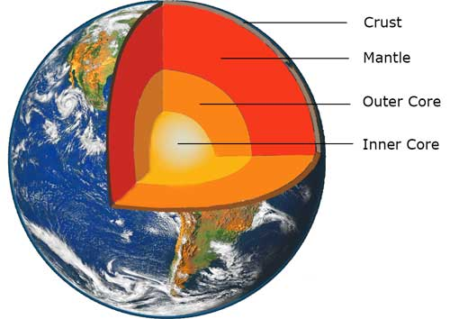

Tectonic Plates

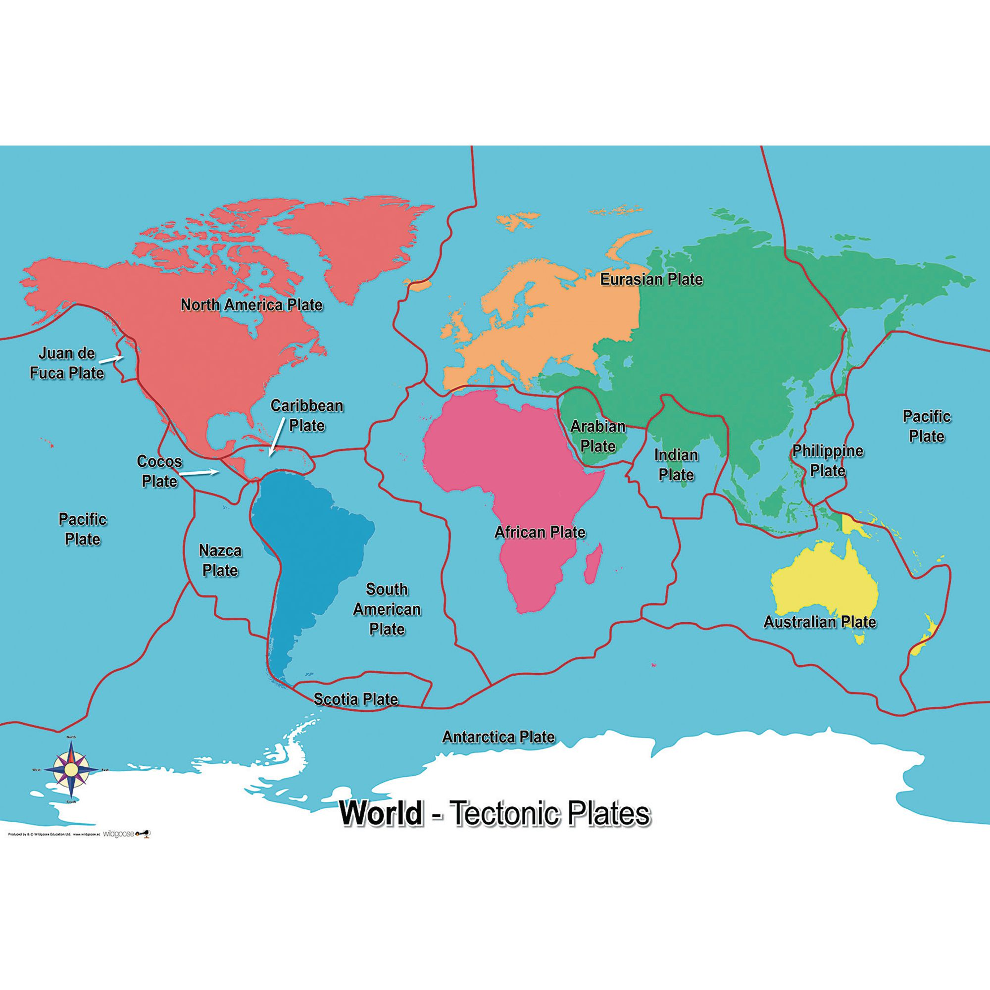

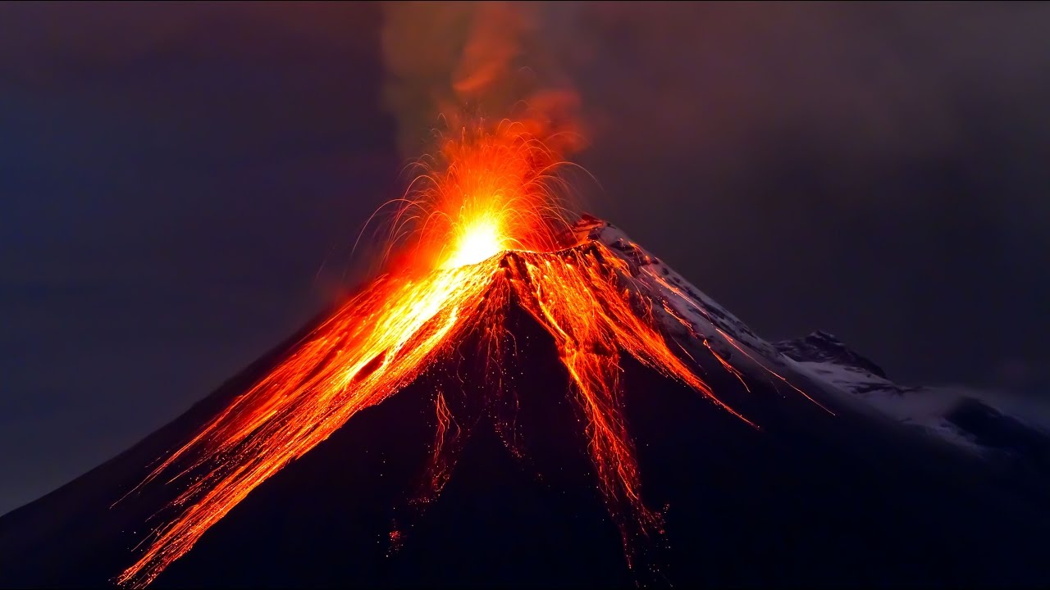

A cross section of a volcano

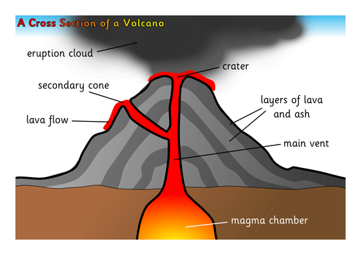

Not all volcanoes are neat cone shapes like this one.

Active, Dormant or Extinct.

Active Volcanoes may erupt at any time.

Dormant Volcanoes have not erupted for some time

Extinct Volcanoes will never erupt again.

What makes a Volcano Erupt?

A volcano erupts when pressure in the

molten rock in the mantle beneath the

volcano builds up until

the magma is forced to burst out

of the top of the volcano.

Volcanoes of the World

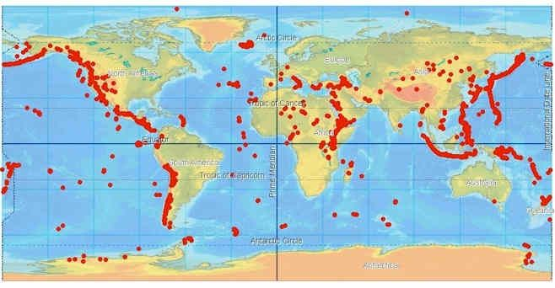

Volcanoes are nearly always found at the place where 2 plates meet.

Famous volcanoes

These include Mount Vesuvius in Italy, Mount Kilauea in Hawaii, Krakatoa in Indonesia and Yellowstone Park in USA which is a super volcano.