On this map of Europe, our continent, you can see the different countries shown in different colours

The Mediterranean Sea is in the middle of 3 continents; Europe, Asia and Africa

**My Knowledge Organiser – Europe Year 3**

**Vocabulary**

|  |  |
| --- | --- |
| Continent | There are 7 continents in the world and each one is made up of several countries |
| Country | A country is a place that has its own government and laws. It may have its own language, traditions and way of life. |
| Capital City | The main city of a country where the government building are |
| Europe | Europe is the continent our country, England, is in |
| Physical feature | A feature on the Earth that is created naturally. Not man-made |
| Human feature | A feature on the Earth that is created by people. Not nature |
| Locality | The area around where you live. |
| Grid Reference | The letters and numbers we use to help find places on maps and in atlases |
| Compass | A special device we can you to find the direction we need to travel in or face |
| Mediterranean | The largest sea that is found in Europe |
| Climate | The weather we expect to see in different places in the world over many years |
| Weather | The wind, rain, sunshine that happens every day in our atmosphere |

Europe

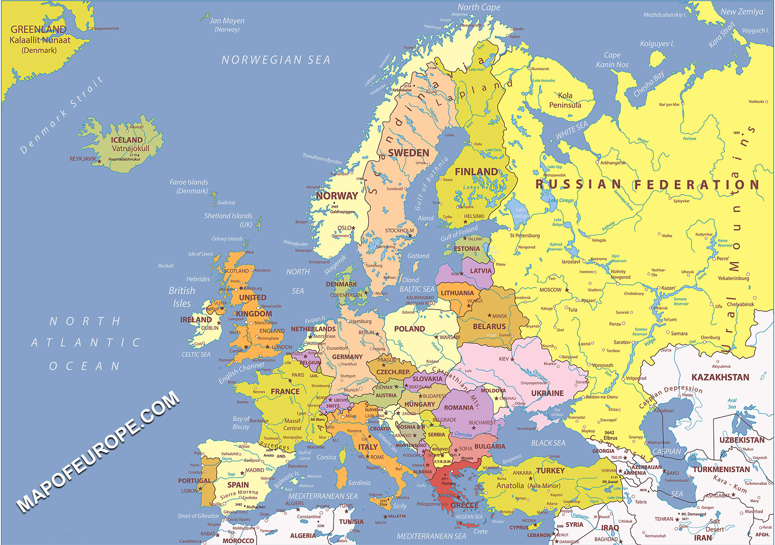

Mediterranean Sea

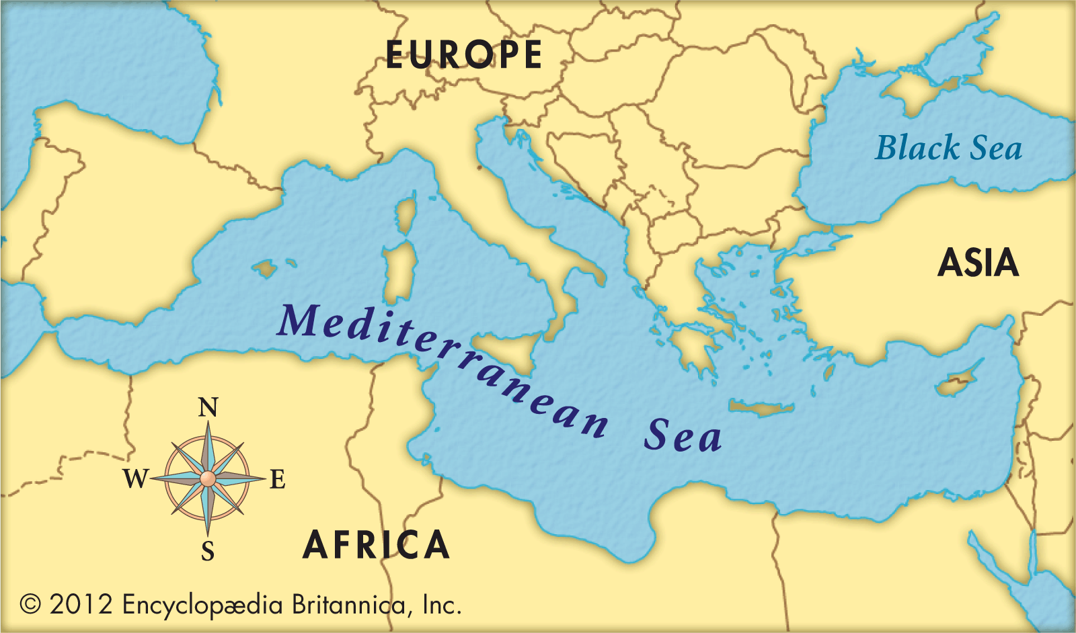

Human features are features we see in our world made by people such as roads, buildings and parks.

Physical features are features we see in our world made by nature.

A compass can help us find

our way.

They are often drawn onto maps and show these

8 points

A real compass

Points of a Compass

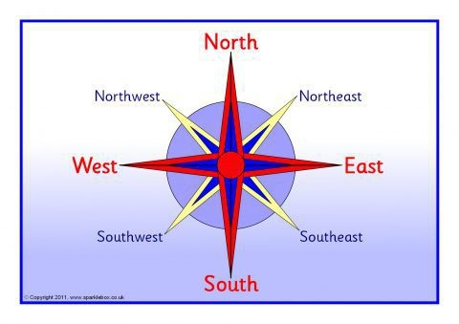

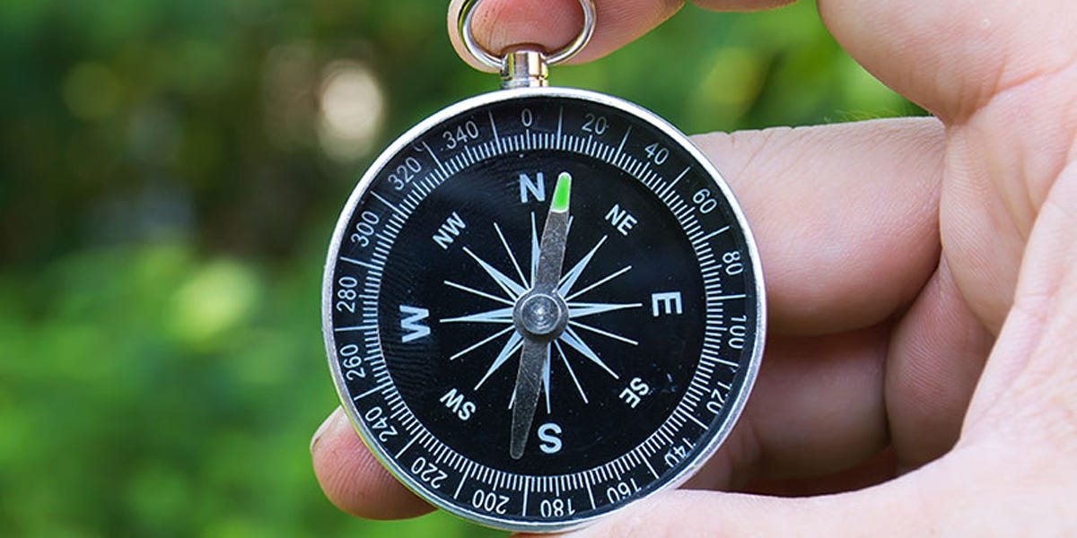

Physical Features

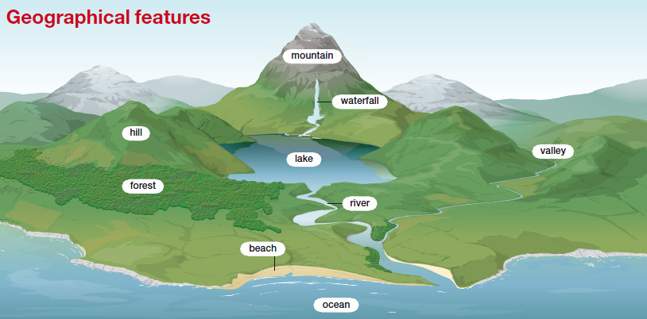

Human Features

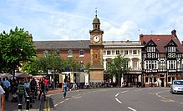

Blue shows cooler places, red shows warmer places.

If the climate is very cold, you will find ice and snow. covered lands.

If the climate is hot and wet, you will find rainforests.

If the climate is hot and dry, you will find deserts.

Climate

This map of the world shows the expected temperature of places in the world.

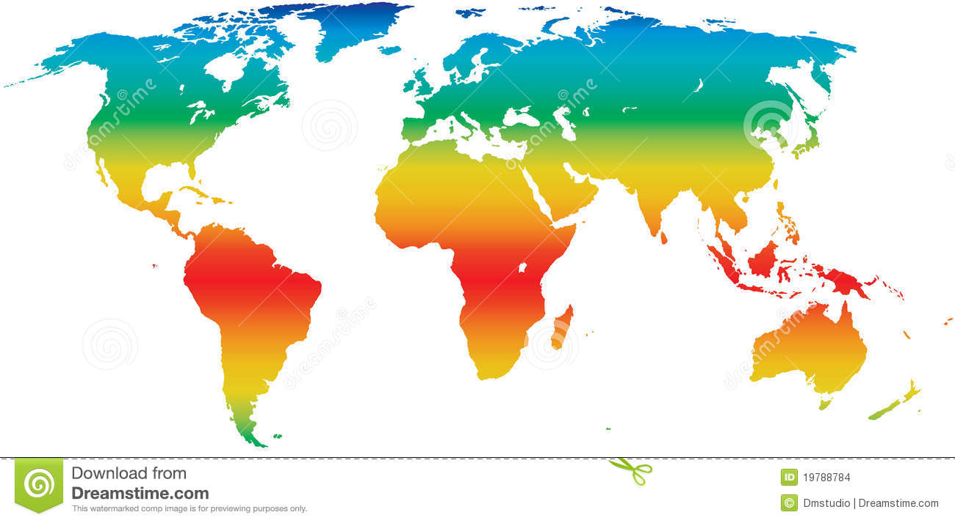

Climate also includes wind, rain, snow.

Closer to the Equator, the climate is warmer and wetter.

Closer to the poles, the climate gets much cooler.

The climate affects what each place is like;

