The Aboriginal people were the first people to live in Australia. They were people who hunted in the outback – the deserts.

On this map of Australia, you can see it is a very large island with hot deserts in the centre and warm wet forests on the west and east coasts.

**My Knowledge Organiser – Australia Year 3**

**Vocabulary**

|  |  |
| --- | --- |
| Continent | There are 7 continents in the world and each one is made up of several countries |
| Country | A country is a place that has its own government and laws. It may have its own language, traditions and way of life. |
| Capital City | The main city of a country where the government building are |
| Village | A small settlement of people and their families. |
| Physical feature | A feature on the Earth that is created naturally. Not man-made |
| Human feature | A feature on the Earth that is created by people. Not nature |
| Locality | The area around where you live. |
| Grid Reference | The letters and numbers we use to help find places on maps and in atlases |
| Compass | A special device we can you to find the direction we need to travel in or face |
| Climate | The weather we expect to see in different places in the world over many years |
| Weather | The wind, rain, sunshine that happens every day in our atmosphere |
| Desert | A very dry place where it is very hard for animals and plants to survive.  In Australia the deserts are very hot |
| Rainforest | Rainforests grow where the weather is very hot and very wet. There are many species of animals and plants found in rainforests |

Australia

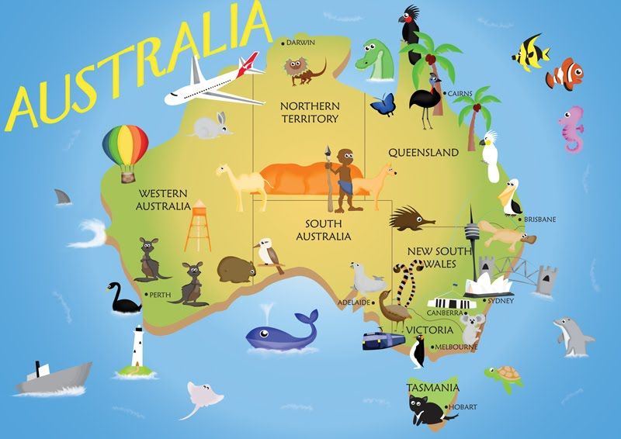

Aboriginal People

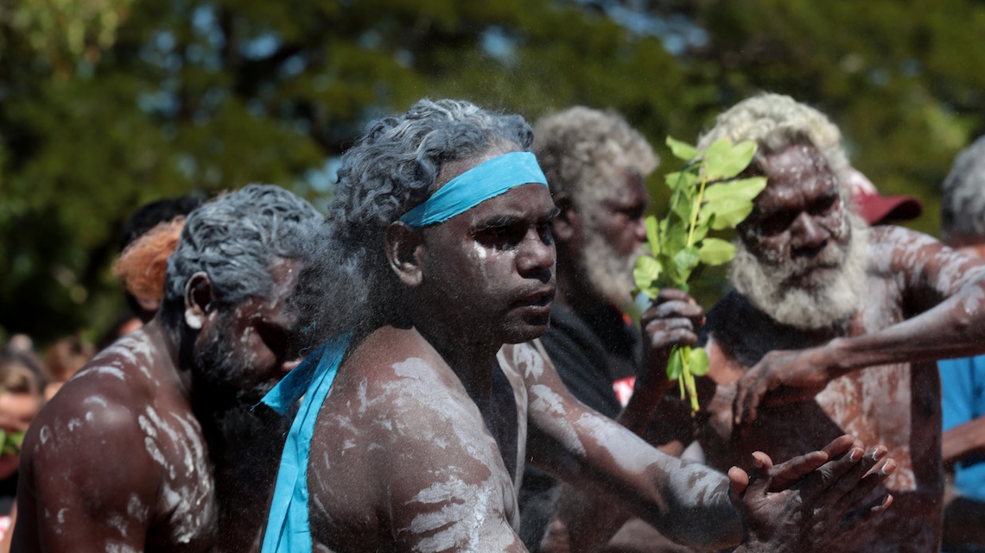

Many of the people who live in Australia now, have come from Europe in the last 100 years.

They live in towns that they have built mostly on the coast, where it is cooler.

In Places on the western and eastern coasts of Australia it is very hot and wet. Rainforests grow very well here.

The Outback is what the native people of Australia call the hot, dry deserts.

They have lived in the outback for many years and hunt and dig for plants to survive.

Uluru is a giant, red, sandstone rock in the outback. It is sacred to the Aboriginal People and is a very famous landmark in Australia.

The Outback

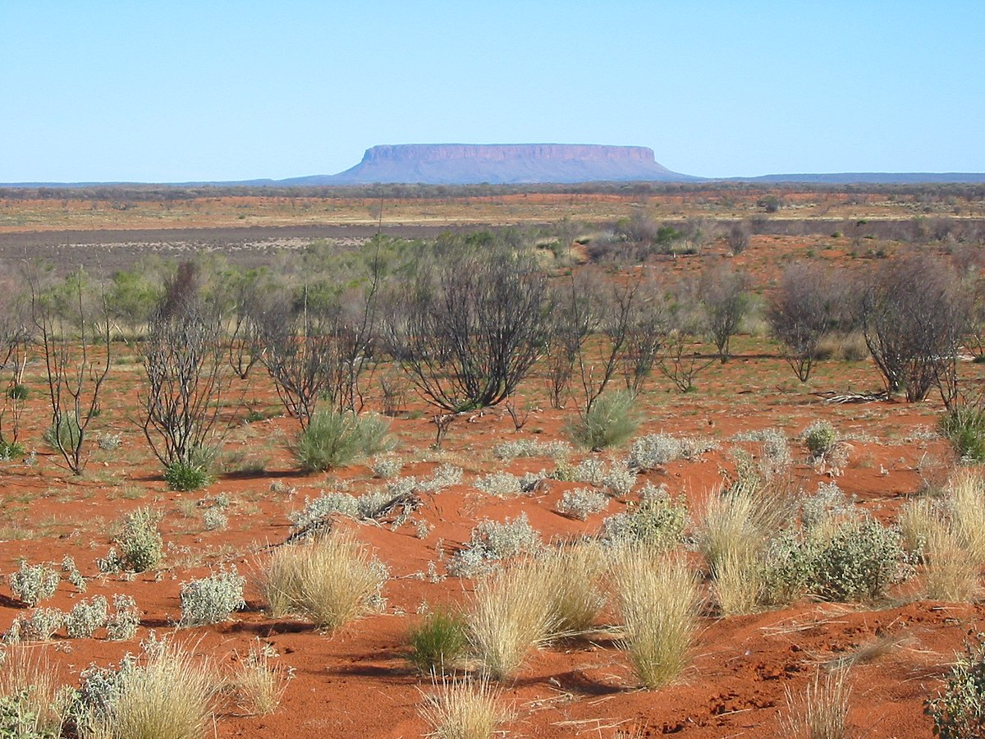

Modern Australians

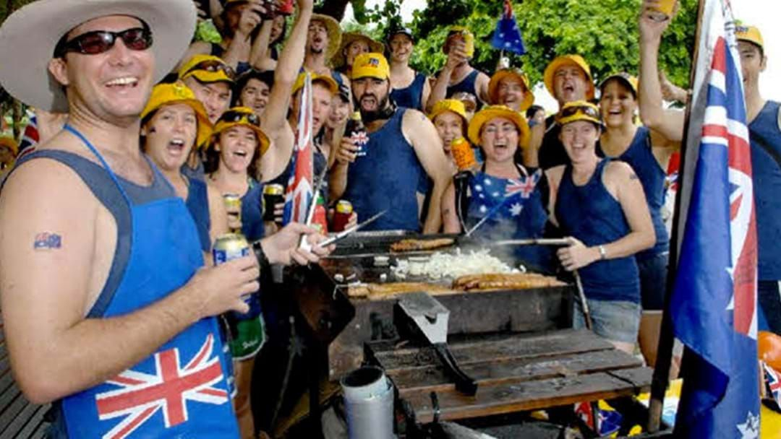

Physical Features

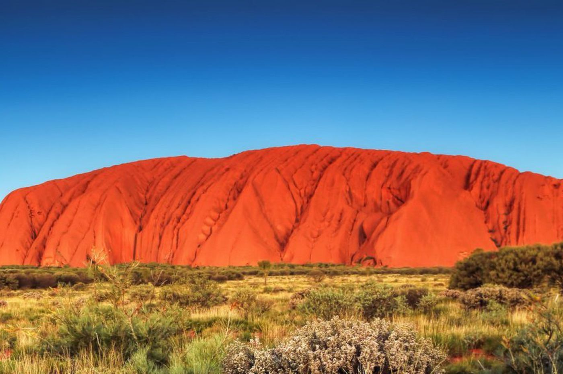

Rainforest

