On this map of India you can see that it is surrounded by oceans in the south and joined to other countries such as China, Nepal, Bangladesh and Pakistan in the north

Chembakolli is a small village in the south of India where it is very warm and hilly and there are many forests.

**My Knowledge Organiser – A Village In India Year 3**

**Vocabulary**

|  |  |
| --- | --- |
| Continent | There are 7 continents in the world and each one is made up of several countries |
| Country | A country is a place that has its own government and laws. It may have its own language, traditions and way of life. |
| Capital City | The main city of a country where the government building are |
| Village | A small settlement of people and their families. |
| Physical feature | A feature on the Earth that is created naturally. Not man-made |
| Human feature | A feature on the Earth that is created by people. Not nature |
| Locality | The area around where you live. |
| Grid Reference | The letters and numbers we use to help find places on maps and in atlases |
| Compass | A special device we can you to find the direction we need to travel in or face |
| Climate | The weather we expect to see in different places in the world over many years |
| Weather | The wind, rain, sunshine that happens every day in our atmosphere |

India

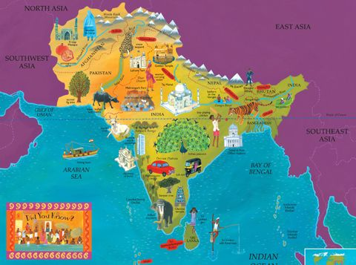

Chembakolli Village

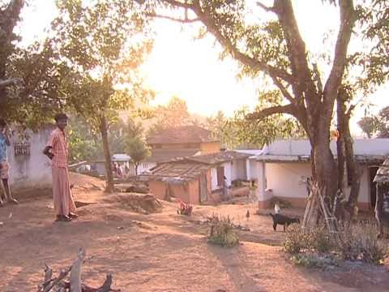

The people in the village eat the food that they grow such as rice and tomatoes.

They buy some food from a local market.

They fetch water from a river and carry it in pots or plastic cans back to their houses.

School in Chembakolli is often held outside and most classes have very few resources that we have in ours.

Not all children go to school as they may have to help their

grown -ups with work

The landscape in Chembakolli is hilly and covered in forests. This makes it hard to farm and grow food

The people who live in Chembakolli live in small, simple houses mostly made of mud and straw.

Most of them are farmers – growing food to eat and keeping their own animals.

The People

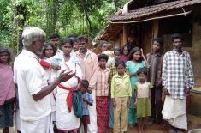

Food and drink

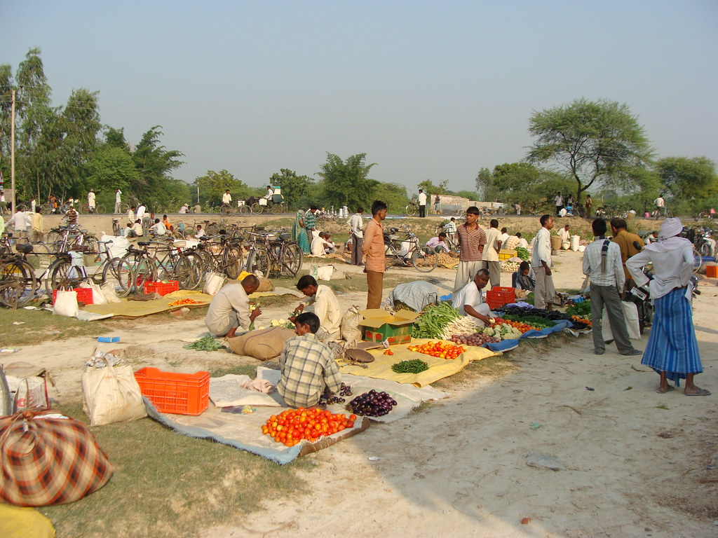

Physical Features

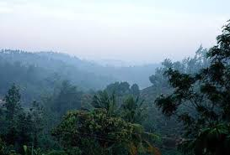

School in the Village

