**My Knowledge Organiser – Weather Year 3**

**Vocabulary**

|  |  |
| --- | --- |
| Climate | The weather we expect to see in different places in the world over many years |
| Weather | The wind, rain, sunshine that happens every day in our atmosphere |

Climate

This map of the world shows the expected temperature of places in the world.

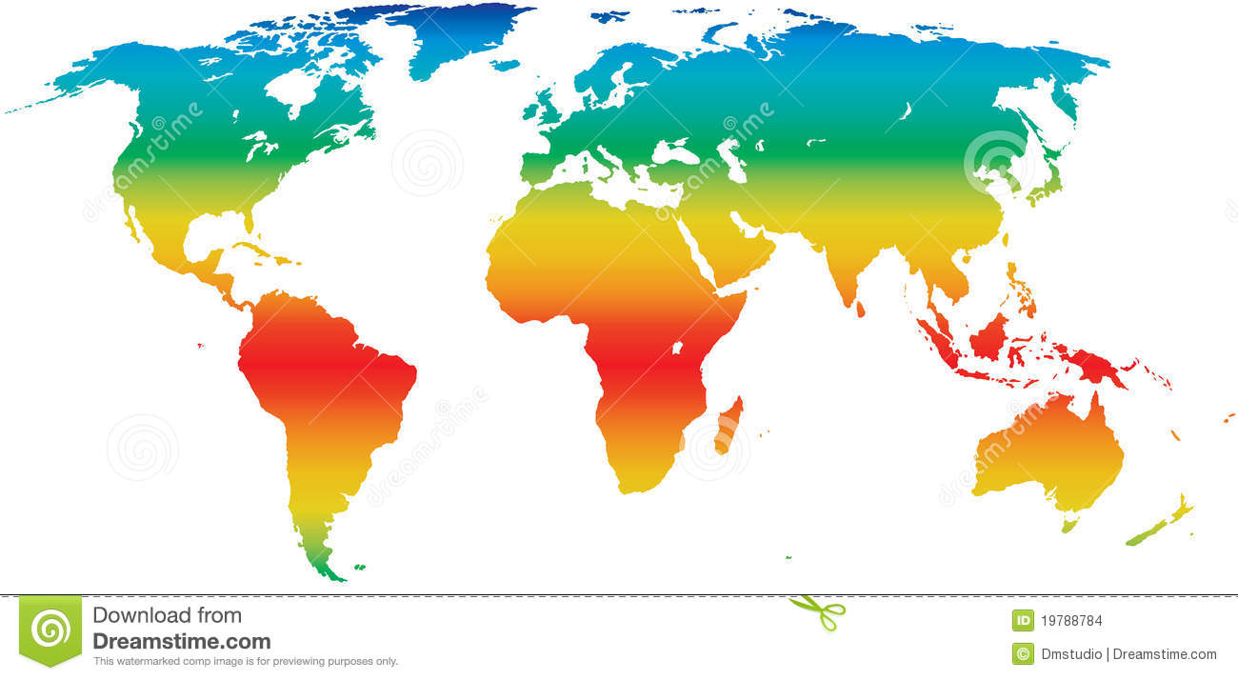

Climate also includes wind, rain, snow.

Closer to the Equator, the climate is warmer and wetter.

Closer to the poles, the climate gets much cooler.

The climate affects what each place is like;

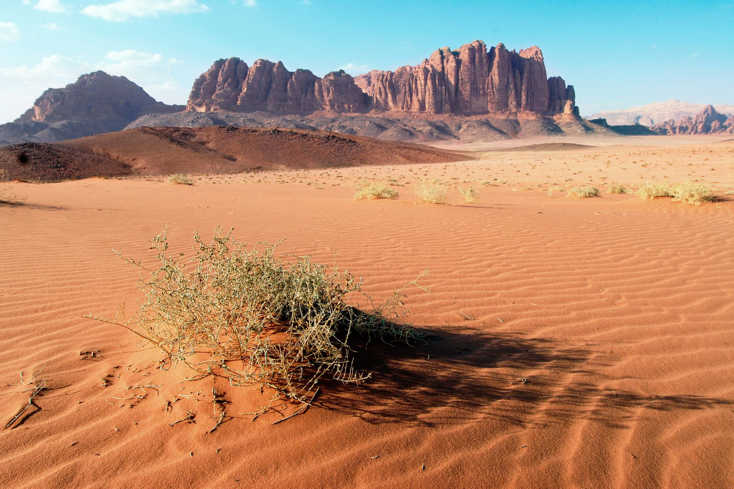

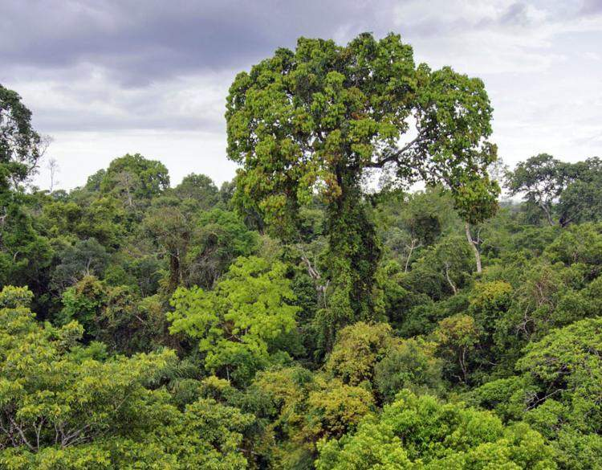

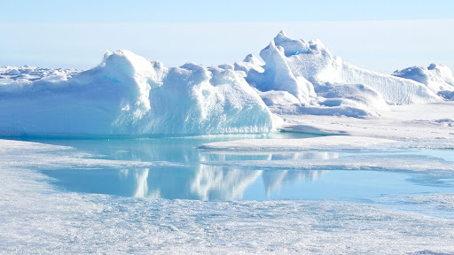

Blue shows cooler places, red shows warmer places.

If the climate is hot and wet, you will find rainforests.

If the climate is hot and dry, you will find deserts.

If the climate is very cold, you will find ice and snow covered lands.