# Knowledge Organiser: Deserts

|  |
| --- |
| **Desert** |
| Deserts are dry areas that receive very little rain. |
| Deserts can be hot or cold. |
| Most hot deserts are found near the **equator.** |

## Sahara Desert

**Key Vocab**

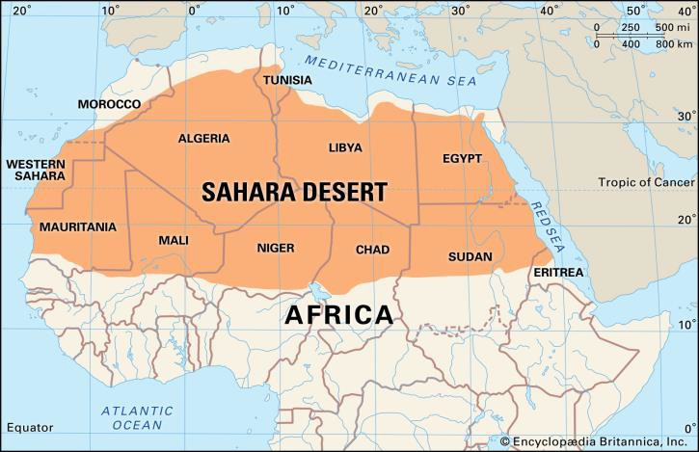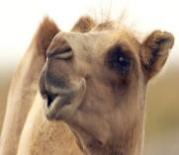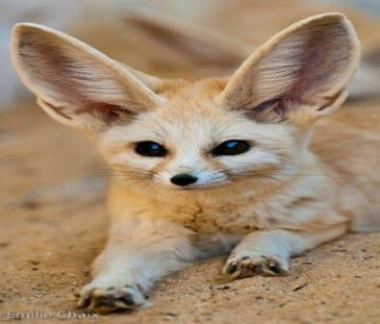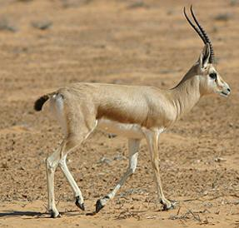

## How Some Species Adapt to Survive in the Sahara Desert

Animals find clever ways to adapt in the Sahara desert. Some are nocturnal, only coming out at night when it’s cool and others can go days without drinking.

Camels have two rows of eyelashes to protect their eyes from the dust; they have fat in their hump so they can go days without food and they can even close their nostrils to stop them inhaling sand.

Gerbils are excellent burrowers. Living in a burrow enables gerbils to escape the intense heat of the day. The sand insulates their little nest, keeping it safe from the burning heat and helping it protect against the chill of a cloudless desert night.

Fennec foxes have bat-like ears that radiate body heat and help keep them cool. They also have long, thick hair that insulates them during cold nights and protects them from hot sun during the day. Even the fox's feet are hairy, which helps them perform like snowshoes and protects them from extremely hot sand.

The dorcas gazelle can go without drinking for its entire lifetime, but when water is available, it does drink.

The largest hot desert in the world is the Sahara.

The Sahara desert is located in North Africa The Sahara is the hottest large area on Earth.

Around 2.5 million people inhabit the Sahara. Most people in the desert are **nomads** or people who move place to place, but they raise sheep, goats, and camels. They move in their tents when the grass is eaten in a place. They usually settle in or near an oasis. Some people raise crops on **irrigated** land.

### Dorcas gazelle

Fennec fox

**Climate**

**Equator Irrigation Biome**

**Desert Species**

**Inhabit Fertile**

**Nomad**

**Population**

### A description of the average weather conditions in a certain place

An imaginary circle around the

middle of the Earth

The artificial supply of water to agricultural land

Areas of our planet with similar climates, landscapes, animals and plants.

Dry areas that receive very little rain

A group of animals, plants or other living things that all share common characteristics.

### To live or dwell in a place

Land or soil that is fertile is able to support the growth of a large number of strong healthy plants.

A member of a people having no permanent home but moving from place to place usually in search of food or to graze livestock

### The whole number of people living in a country, city, or area

Knowledge Organiser Geography: Desert Biome

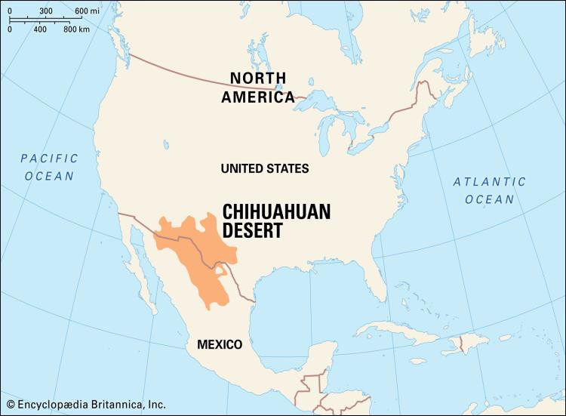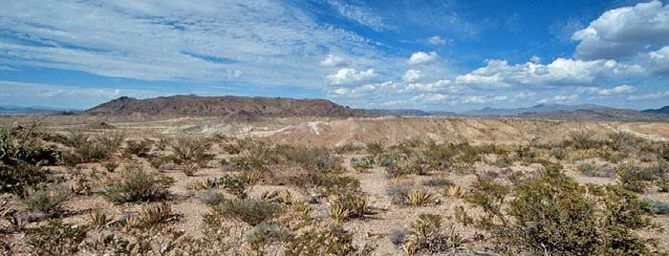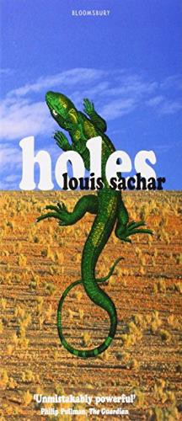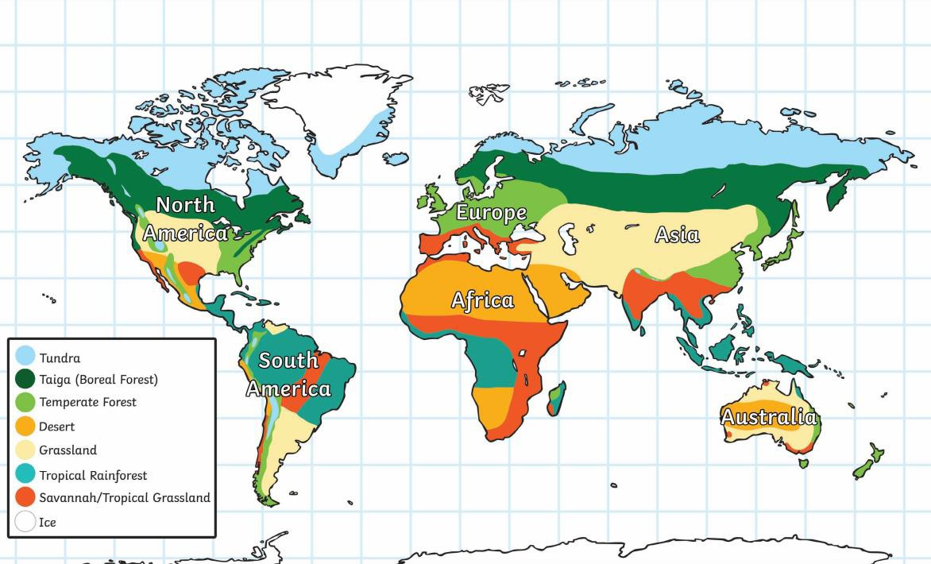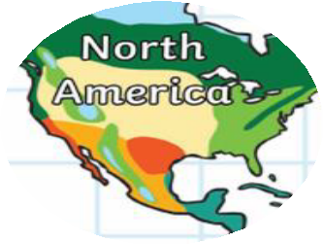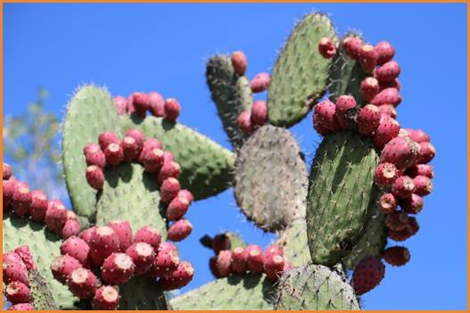

|  |
| --- |
| **Chihuahuan Desert** |
| The Chihuahuan desert is one of the largest deserts in North America. It covers parts of northern Mexico and the south-western United States of America. |
| The Chihuahuan desert covers a large area from and as the temperature, soil, height and rainfall changes so does the environment. |
| Down through the central area, the land is much higher and therefore cooler than the lower parts and this affects the **climate**. More plants can grow with more rain and cooler temperatures. |
| A water crisis and other threats, however, are endangering the survival of wildlife and people living in this environment. |
| Little rain falls in the Chihuahuan desert, but the Rio Grande River - known as the Rio Bravo in Mexico - flows through the desert, providing a lifeline for the animal and plants **species**, and the millions of people who live here. |
| The climate in the Chihuahuan Desert is, as you would guess, dry. It only has two seasons, summer and winter. Summer is the rainy season with smaller amounts of rainfall occurring in the winter. |
| The Chihuahuan desert is home to about 345 of the world's 1,500 cactus **species**. The cacti and other plants are a crucial part of the desert ecosystem, providing shelter and food for birds, bats and other animals. |
| The Chihuahuan desert is where the book Holes by Louis Sachar is set. |

Prickly Pear is a species of cactus found in the Chihuahuan desert

The Chihuahuan desert

In the Chihuahuan desert there is around 20-30cm of rainfall per year. Anything that lives here will have to be adapted to living in these dry conditions.