**Continents and Oceans of the World**

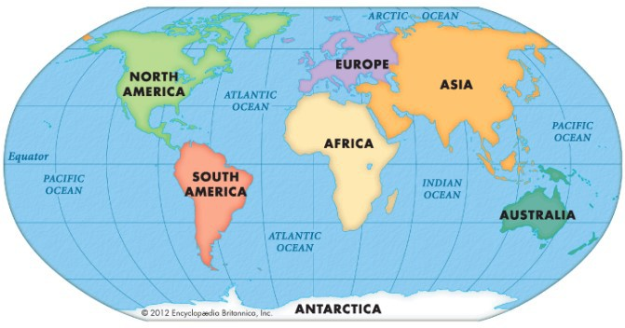

|  |  |  |
| --- | --- | --- |
| **Continent** | **Some major countries** | **Capital Cities** |
| Asia | **CHINA**  India  Japan | Bejing New Delhi  Tokyo |
| Africa | **ALGERIA**  Egypt  Kenya | Algiers Cairo  Nairobi |
| North America | **CANADA**  Mexico  United States of America | Ottawa  Mexico City  Washington DC |
| South America | **BRAZIL**  Argentina | Brasilia  Buenos Aires |
| Antarctica | No countries—no-one  lives here permanently! |  |
| Europe | United Kingdom France  Spain Germany  **RUSSIA** | London Paris  Madrid  Berlin Moscow |
| Australia  (Oceania = region) | **AUSTRALIA**  New Zealand | Canberra  Wellington |

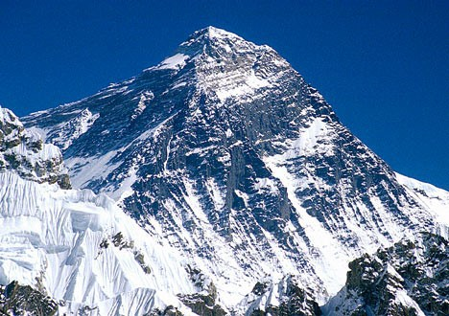The tallest mountain in the world is Mount Everest in Asia. Located in the Himalayas, at it highest point it is 8848 metres above sea level. The border between China and Nepal runs through its summit!

|  |  |
| --- | --- |
| Words | Definition |
| **continent** | A continent is one of Earth’s seven main divisions of land. From largest to smallest they are: Asia, Africa, North America, South America, Antartica,  Europe, Australia (Oceania=region). |
| **country** | An area of land that has its own government and borders that separate it  from another country. |
| **city** | A large town, where many people live closely together. |
| **capital city** | The main city of a country where its government is officially based. |
| **climate** | Climate means the usual type of weather in a particular area and this in-  cludes temperature, rainfall and wind speed. |
| **population** | The population of a particular place is the total number of people living  there. |
| **physical features** | The characteristics of a place, including landform (mountains, hills, valleys),  rivers, climate etc. |
| **human features** | The characteristics of a place, including language, religion, buildings, etc. |
| **Equator** | An imaginary line encircling the Earth, midway between the North and South Poles, dividing the Earth into the Northern and Southern hemi-  spheres. |
| **Tropics** | The area of the Earth, close to the Equator, between the Tropic of Cancer  and the Tropic of Capricorn (imaginary lines encircling the Earth). |

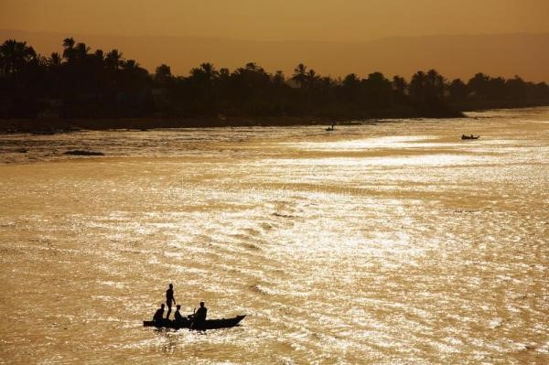The longest river in the world is the River Nile. It runs through 11 countries and is approximately 6650 kilometres long. There are two major branches of the river: the

White Nile (starting in Uganda ) and the

Blue Nile (starting in Ethiopia). It emerges into the Mediterranean Sea by Egypt.