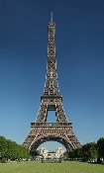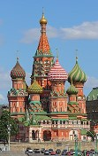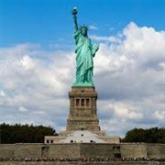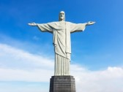

|  |  |  |  |  |  |
| --- | --- | --- | --- | --- | --- |
| **Geography** | | | | |  |
| **Topic: Countries and Cities of the**  **World** | **KS2** | | **Locational Knowledge / Human and**  **Physical Geography** | |
|  |  | **Vocabulary** | | | |
| |  | | --- | | **What I already know** | | I live in a **city** called **Chelmsford** in the **county** of **Essex**. I live in England which is part of the United Kingdom. I live in the **continent** of **Europe**.  There seven **continents** (including Europe) and five **oceans**.  The main **climate zones** across the world and the **biomes** that can be found there.  The similarities and differences between Chelmsford and differing places from different continents | | | atlas | | book of **maps** | |
| biome | | a natural area of the living world which has its own **climate,**  **vegetation** and animals | |
| capital city | | the **city** where the government sits. London is the **capital city** of  England and the UK. | |
| city | | a large town. London is a **city**. | |
| climate | | the [general](https://www.collinsdictionary.com/dictionary/english/general) weather conditions that are typical of a place | |
| climate  zone | | sections of the Earth that are divided according to the climate.  There are three main **climate zones**; polar, **temperate** and **tropical**. | |
| coasts | | an area of land that is [next](https://www.collinsdictionary.com/dictionary/english/next) to the **sea** | |
| compass | | any of the [main](https://www.collinsdictionary.com/dictionary/english/main) points of a compass: north, south, east, [west,](https://www.collinsdictionary.com/dictionary/english/west) | |
|  | |  | |
|  |  | continent | | a very large area of land that consists of many **countries**. Europe is  a **continent**. | |
| |  | | --- | | **Geographical Skills/Fieldwork** | | **Find the countries** using a map, an **atlas** and a **globe**. What are the skills you need to use each of these?  Compare the **human** and **physical geographical** features of the **countries** saying how they are similar and different.  Research the different **climate zones** in each country.  Research the average temperature for each of the **countries.**  Observeaerial view photographs to compare **countries** and **climate zones**  Use the **compass points** to describe the **countries** in relation to each other. | | |
| country | | an area of land that is controlled by its own government. | |
| desert | | a large area of land, usually in a [hot](https://www.collinsdictionary.com/dictionary/english/hot) region, where there is almost  no water, [rain,](https://www.collinsdictionary.com/dictionary/english/rain) trees, or plants | |
| equator | | an [imaginary](https://www.collinsdictionary.com/dictionary/english/imaginary) [line](https://www.collinsdictionary.com/dictionary/english/line) around the [middle](https://www.collinsdictionary.com/dictionary/english/middle) of the Earth at an equal  [distance](https://www.collinsdictionary.com/dictionary/english/distance) from the North Pole and the [South](https://www.collinsdictionary.com/dictionary/english/south) Pole. | |
| globe | | a ball-shaped object with a map of the world on it | |
| human  geography | | features of land that have been impacted by human activity | |
| landmark | | a building or feature which is easily recognised | |
| language | | the communication of a particular **country** or people | |
| ocean | | one of the five very large areas of salt water on the Earth's surface | |
|  | | physical  geography | | natural features of land | |
|  | | population | | all the people who live in a **country** or area | |
|  | | sea | | a large area of salty water that is part of an **ocean** | |
|  | | tectonic | | relating to the structure of the Earth's surface or crust. | |
|  | | temperate | | a place which is never extremely hot or extremely cold | |
|  | | tourist | | a person who is visiting a place for pleasure and interest, especially  when they are on holiday. | |
|  | | trade | | the activity of buying, selling, or exchanging goods or services | |
|  | | tropical | | parts of the world that [lie](https://www.collinsdictionary.com/dictionary/english/lie) between the imaginary lines; **Tropic** of Cancer and the **Tropic** of Capricorn. The **tropics** have a humid  **climate**, where the weather is hot and damp. | |
|  | | tundra | | a flat layer of land where the top layer is frozen. There is hardly any  **vegetation**. | |
| Brazil | | vegetation | | plants, trees and flowers | |

points north-east, north-west, south-east, south-west

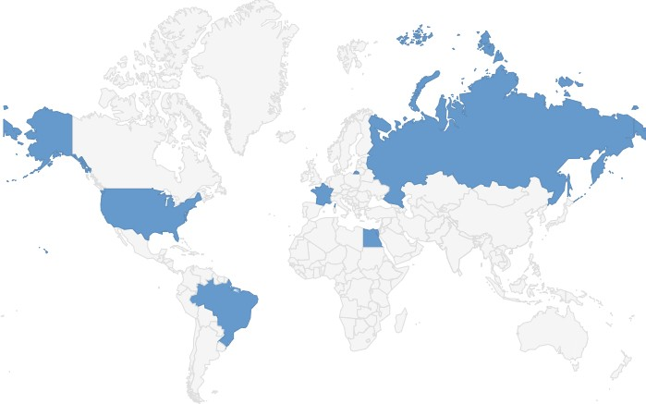

|  |  |  |  |  |
| --- | --- | --- | --- | --- |
| **What will I know by the end of the unit?** | | | | |
| **Country** | **Capital City** | **Continent** | **Human Geography** | **Physical Geography** |
| France | Paris | Europe | * famous **landmarks**: Eiffel Tower, Disneyland * **trade** - farming, fashion, wine * high levels of **tourism** * Main **language**: French | * mountain ranges including the Alps * rivers , including the Seine * warm summers and cool winters (**temperate**) * has **coasts** on the English Channel |
| Russia | Moscow | Europe | * famous **landmarks**: St Basil’s Cathedral * **trade** - energy (oil, gas and coal) * largest **population** in Europe * Main **language**: Russian | * largest country in Europe by land * due to its size, there are many **climate** zones * has a **coast** on the Arctic **Ocean** - this part of Russia consists of a **tundra biome** |
| United States of America (USA) | Washington DC | North America | * famous **landmarks**: the White House in Washington DC and the Statue of Liberty in New York * **trade** - farming, technology, **tourism** * high levels of **tourism** * divided into states * Main **language**: English | * mountain ranges including the Rocky Mountains * Niagara Falls, waterfall * due to its size, there are many **climate** zones including **deserts** and Arctic **tundra** * has **coasts** on the Atlantic and Pacific **Oceans** * lies on the edge of a **tectonic** plate |
| Brazil | Brasilia | South America | * famous **landmarks**: the Christ the Redeemer statue * famous for the carnival held in Rio de Janeiro * **trade** - sugar, coffee * Main **language**: Portuguese | * Amazon rainforest **biome** and river * **tropical climate** * Lies on the line of the **equator** * **Coasts** on the Atlantic **Ocean** |
| Egypt | Cairo | Africa | * famous **landmarks**: the Great Pyramid of Giza * Suez Canal joins the Mediterranean and Red Seas * popular for **tourists** due to hot weather and pyramids * Main **language**: Arabic | * hot, dry **climate** - consists of **desert biomes** * River Nile * **coasts** on the Mediterranean and Red **Seas** * Lies on the line of the **Tropic** of Cancer |