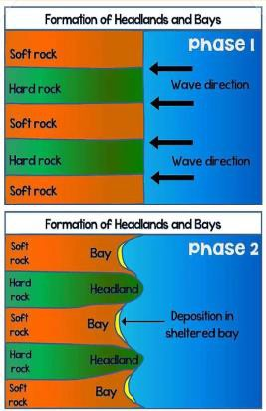

|  |  |
| --- | --- |
| **What? (Key Knowledge)** | |
| Ocean processes | Waves are created by the movement of air across the sea. Tides are created by the gravitational pull of the moon. |
| How are coastal land forms formed | The sea’s waves lead to hydraulic action and erosions of the land. The land is made up of different rocks, some hard some soft, leading to bays and headlands. Further erosion leads to cracks, caves, arches, stacks and stumps. |
| What are coasts | Coasts are where the land meets the ocean. This can take different forms such as beach (sand, shingle, pebble) and cliffs. |
| Land use and economy | Coastal areas attract tourism, and residential areas. Coastal erosion can threaten land use, and so beach protection measures, such as rock armour, groynes, and sea walls, are created. |
| Maps | Children can use a range of maps, including OS, and aerial photographs to identify and describe coasts. |
| Global issue | Ocean plastic, and beach litter. Beaches are becoming poisonous habitats due to human activity. |

|  |
| --- |
| **Coastal Erosion** |

|  |  |  |  |
| --- | --- | --- | --- |
|  | | **What? (Key vocab)** | |
| **Spelling** | **Definition** |
| Coast | The area where the land and sea meet. |
| Beach | A low lying area where the land meets the sea, made up of fine, lose sediment |
| Cliff | A high altitude area where the land meets the sea, made of hard rock |
| Erosion | The process where material is  removed from the land |
| Headland | An area of land protruding into the sea. |
| Bay | And area of sea protruding into the land |
| Longshore drift | The process through which sediment is moved across a beach. |
| Hydraulic action | the weight of a wave crashing on a cliff face, pushing the air in cracks and caves, under pressure, to force open the crack/cave |
| Ocean plastic | Plastic which has been littered and pollutes the seas and coasts. |
| **Diagrams and Symbols** |  | **Possible experiences** | |
| Compare and contrast different coastal regions  To model, using clay, the different coastal formations.  Model bays and headlands in the classroom with rocks and sand.  Using maps and aerial photos to describe coastal areas  Children to design their own method of preventing coastal erosion. Can do this practically using sand in and water in the classroom. | |
|  |