Describe the physical features of their own locality e.g. fields, rivers, forests, woodland, hills, lakes, vegetation | 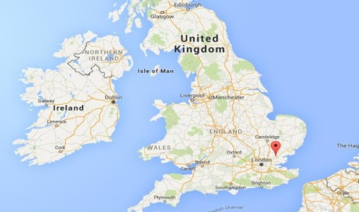  Find where they live on a map of the UK | Label maps, photos, pictures and diagrams with some geographical words
Describe the human features of their own locality e.g. city, houses, shops, roads, offices, factories | Local Study:  Chelmsford and the UK  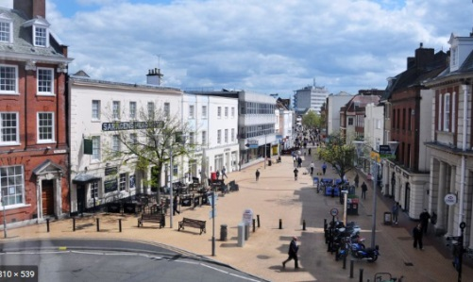 | Say what Chelmsford is like and what facilities it has to make it special e.g. a Cathedral, Leisure Centre, Parks , play areas, restaurants
Find out about their locality by using different sources of evidence | How do people sometimes spoil the area and how do people try to make the area better | Find out what jobs people have in their locality by carrying out a survey

