|  |  |  |  |  |
| --- | --- | --- | --- | --- |
|  | | | | |
| **Climate Change** |  | | **Strand: Human and Physical Geography (Concept: Biomes and Climate Change)** | |
| * The seven **continents** (including Antarctica) and five **oceans** of the world. * Examples of some countries around the world and what the **climate** is like there. * What **climate** means and how it affects the **vegetation** in an area. * Different **biomes** around the world, including the **polar tundra** and some countries where it can be located. * What plants need to survive. * How **seasonal** changes can affect the **weather** and **vegetation** * Different **habitats** and some plants and animals that can be found there.   **What should I already know?** | | **Vocabulary** | | |
| arctic | | the area of the world around the North Pole. It is extremely cold and there is very little light in winter and very  little darkness in summer |
| barren | | A **barren landscape** is dry and bare, and has very few plants and no trees. |
| biome | | a natural area of **vegetation** and animals |
| climate | | the [general](https://www.collinsdictionary.com/dictionary/english/general) weather conditions that are typical of a place |
| climate change | | changes in the earth’s **climate**, especially the gradual rise in **temperature**, as a result of human activity |
| continent | | a very large area of land that consists of many countries. Europe is a **continent**. |
| environment | | all the [circumstances,](https://www.collinsdictionary.com/dictionary/english/circumstance) people, things, and events around them that influence their life |
| frozen | | when something has become a solid because of low **temperatures** |
| global | | something that happens in all parts of the world or affects all parts of the world |
| habitat | | the [natural](https://www.collinsdictionary.com/dictionary/english/natural) environment in which an animal or **plant** normally lives or grows |
| harsh | | **Harsh climates** or conditions are very difficult for people, animals, and plants to live in |
| landscape | | everything you can see when you look across an area of land, including hills, rivers, buildings, trees, and plants. |
| melting | | to change from a solid to a liquid state through heat or pressure |
| mountain | | a very high area of land with [steep](https://www.collinsdictionary.com/dictionary/english/steep) sides |
| nutrients | | substances that [help](https://www.collinsdictionary.com/dictionary/english/help) plants and animals to grow |
| ocean | | one of the five very large areas of salt water on the Earth's surface. |
| permafrost | | land that is **permanently frozen** to a great depth |
| permanent | | Something that is **permanent** lasts for ever |
| plain | | a large flat area of land with very few trees on it |
| polar | | near the North and South Poles |
| seasons | | main periods of the year that can have their own **weather** conditions |
| sustain | | continue or maintain something for a period of time |
| temperature | | a measure of how hot or cold something is |
| tundra | | a flat layer of land where the top layer is frozen. There is hardly any **vegetation**. |
| vegetation | | plants, trees and flowers |
| weather | | the condition of the [atmosphere](https://www.collinsdictionary.com/dictionary/english/atmosphere) in one area at a particular time, for example if it is [raining,](https://www.collinsdictionary.com/dictionary/english/rain) [hot,](https://www.collinsdictionary.com/dictionary/english/hot) or [windy](https://www.collinsdictionary.com/dictionary/english/windy) |

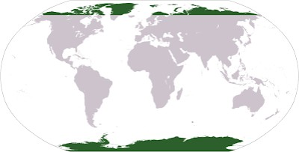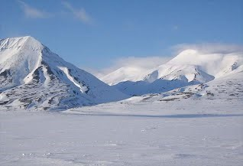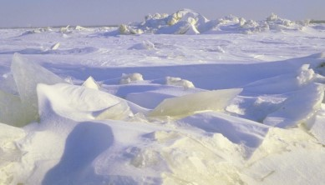

* Locate where the **polar biomes** can be found using maps, globes and atlases. Locate the countries that the **arctic tundra** can be found in.
* Describe the **climate** in the **polar biomes** and explain why this is the case.
* Explain the effect that **climate change** has on the **arctic tundra.**
* Explain why there is a lack of **vegetation** in the **polar biomes.**
* Compare the **vegetation** in the **polar biomes** to that of a woodland or forest and explain the similarities and differences.
* Look at digital maps of the **arctic tundra** over time. What do you notice? Why is this the case?
* Analyse bar charts that show average **temperatures** in the **tundra** at different times of the year.
* Explain what humans can do to help combat the effects of **climate change.**

**Geographical Skills and Fieldwork**

* The **polar biomes** (which include the **arctic tundra)** are **harsh environments**

that only the toughest plants and animals can survive in.

* The **habitat** has a long and brutal winter and the **barren landscape**

provides many challenges.

* While the **arctic tundra** is confined to only the areas near the north pole, other areas that are part of the **tundra biome** can be found in Antarctica and certain cold, **mountainous** regions.
* Unfortunately, the **arctic tundra** is shrinking as a result of **climate change**; the increasing **temperatures** are causing the **permafrost** to **melt.**

**Permafrost:**

* The thin layer of top soil in the **arctic tundra thaws** during the summer months, but beneath that the ground is **permanently frozen**.
* **Permafrost** currently covers approximately 20% of the earth's surface, but this amount is shrinking rapidly due to increases in **global temperatures**
* **Permafrost** is very challenging to build on, which is one of the reasons that very few people inhabit the **tundra**.

**Landscape:**

* Since the ground is **frozen** in the **tundra**, most plants are not able to grow their roots beneath the top soil or receive enough **nutrients** from the soil to **sustain** their growth.
* The plants that are able to grow are usually small in height and sprawl across the ground—giving the **tundra** a **barren landscape**.
* The summer is very short in the **tundra**, which also limits the ability of most plants to grow. The term **tundra** actually refers to a “treeless **plain**” or

“**barren** land”.

**Climate:**

* The **arctic tundra** is the coldest and driest place on the planet. In the **tundra** the autumn and spring **seasons** are basically non-existent, leaving only two **seasons**—winter and summer.

**The Polar Tundra**