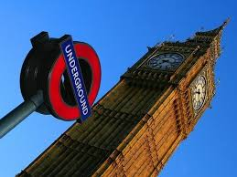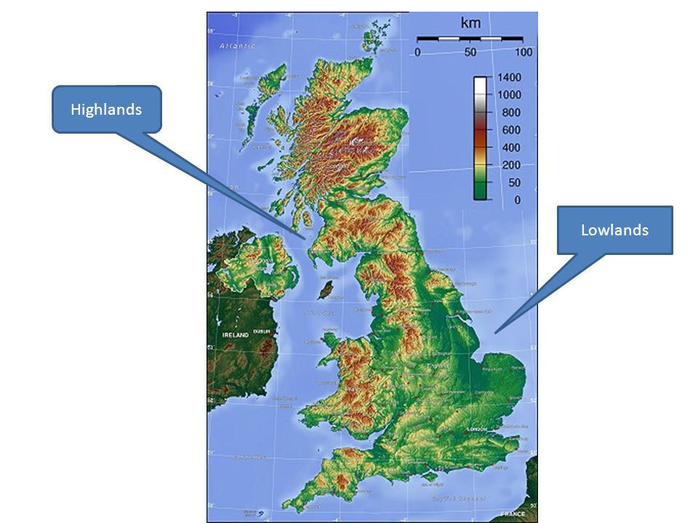

**The British Isles**

Physical features are naturally created by the Earth.

Human features relate to something that is created by human, and would not have existed in nature without humans.

**Great Britain** = England, Wales and Scotland

**UK** = England, Wales, Scotland and Northern Ireland

**British Isles** = England, Wales, Scotland, Ireland and at least 70 small islands

The Tropic of Cancer lies 23.5 degrees north of the Equator. The Tropic of Capricorn is 23.5 degrees south of the Equator.

Physical and Human Geographical Features are represented on maps using symbols