|  |
| --- |
| **Possible experiences** |
| Use atlases to explore the country, and  identify key facts.  Be given photos of countries, items of food, artefacts etc . and reason if they link to UK or other country,  Complete graph work comparing climates of UK and other country.  Show news reports of the recent fires, and deforestation in the **Amazon**. Debate the statement. Increasing farming brings more money to the country, so deforestation is a necessary evil |

|  |  |
| --- | --- |
| **The Amazon & Brazil** | **Continent - South America** |

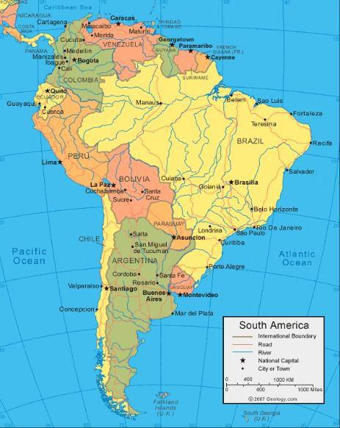

**Diagrams and Symbols**

|  |  |
| --- | --- |
| **What? (Key Knowledge)** | |
| Basic Facts | Continent: South America Country: Brazil  Capital: Brazillia Currency: Brazilian real Language: Portugese |
| Flag |  |
| Human Feature | Indigenous cultures and persecution. Urban migration and urbanisation The expansion of the farming industry causing deforestation. |
| Physical Features | Amazon river (the longest in the word), and the Amazon rainforest are located there. |
| Climate | The climate of Brazil varies considerably, from tropical areas in the North, to more temperate zones South of the Tropic of Capricorn |
| Global Issues | Persecution of indigenous tribes in the Amazon rainforest.  Destruction of the natural habitats to give space for farming. |

|  |  |
| --- | --- |
| **What? (Key vocab)** | |
| **Spelling** | **Definition** |
| Human Features | A manmade feature (cities, roads, farming) |
| Physical Features | A natural feature on the environment (mountains, beaches, forests) |
| Migration | The movement of people within a nation |
| Urbanisation | The process of making an area more urban (cities and towns grow) |
| Persecution | The systematic ill-treatment of a group or individual. |
| Deforestation | The destruction of vegetated areas |
| Wild fires | Naturally occurring fires brought on through dry, hot weather |
| Tropic of Capricorn | An imaginary line south of the Equator |
| Climate Change | The altering of weather patterns across time. |