Dear Meadgate families,

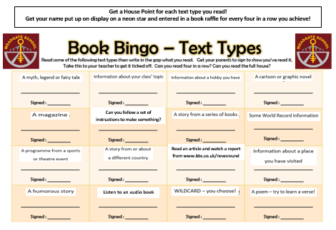How lovely to have your children back at school learning in our classrooms and a warm welcome to parents of our new Year 3 class into KS2!

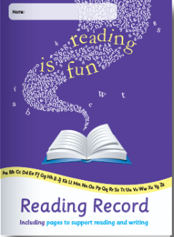Your children will be coming home this week with **a new reading challenge** whichwe would love your child to participate in during the autumn term. The challenge will look like this and will be stuck in your child’s reading record book.

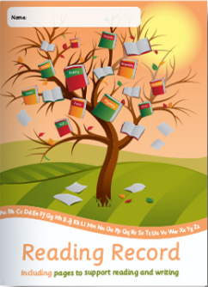The aim is to encourage each child at KS2 to read as broadly as possible and enjoy a range of fiction and non-fiction alongside their usual reading book.

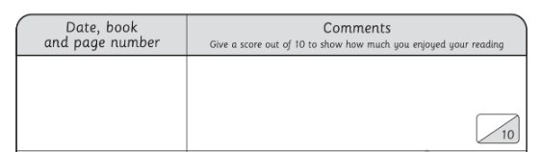 These text types can be read **by the children**, or be read **to the children** – what we are promoting is the love of literature and engagement with reading. Every time your child reads or is read to, please write the title of the book, pages read and a little comment in your child’s reading record. Older children may be able to do this themselves too.

Once your child has finished a book, please jot a note down for their teacher in their reading record book and they will get their name written on a neon star and put on a special reading display in the KS2 corridor. This means other staff members and pupils will be able to congratulate them on their reading and ask them for book recommendations too.

At the end of term, I will take all the stars down and we will have a lucky dip in our last book assembly. **Any names pulled out will win a new book of their own choice!**

Please support us with this challenge – the more your children are exposed to literature, the better their vocabulary understanding, reading comprehension and own writing will be. Thank you and **happy reading!**

Ms Christina Pateman, KS2 phase lead and English subject lead